Suitable locations: Margate Main Sands, Joss Bay, Ramsgate, Minnnis Bay

Wish You Were Here

KS2
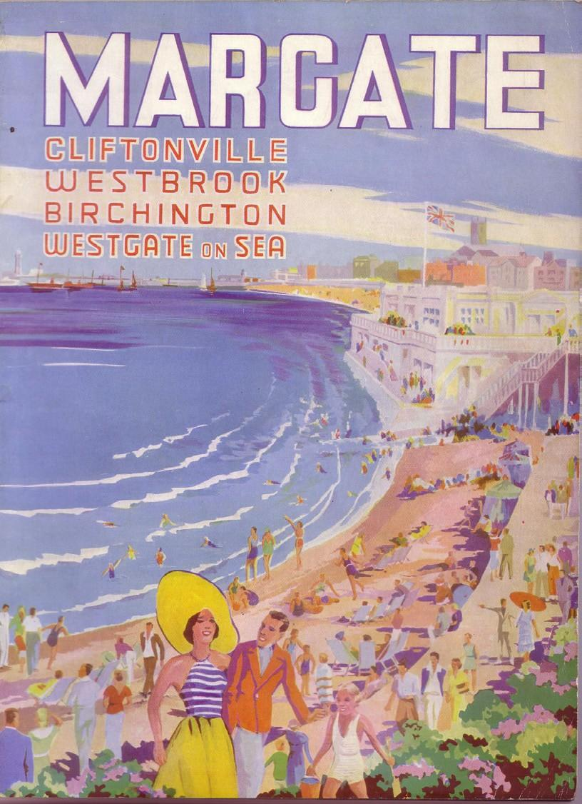
Learning Outcomes
After taking part in this activity children will understand the popularity of seaside postcards in the past and what a broad range of designs were available. They will also have learned and applied their own design skills.
ART

Holiday postcards
DESIGN
A
POSTCARD
Postcards are a distinctive type of written correspondence, designed to be posted without an envelope. The first postcard was sent to a writer in Fulham, London in 1840. In 1894 the Royal Mail allowed British publishers to make and distribute picture postcards through the post. They quickly became popular souvenirs, especially at seaside resorts like Margate, Ramsgate and Broadstairs. People tend to write postcards in a writing style called Postcardese, with short, snappy sentences and often changing subject with each sentence, an early form of Twitter or texting?!

Before the visit
Introduce children to the varieties of seaside postcards using the examples in Wish You Were Here, Resource 6 and 7. Discuss what views and images are used and what design they would like to use for their own card.

During the visit
Children take photographs or make drawings to be used in their postcard design. Get children to think about what makes the place special and encourage them to create images that reflect this. What images would they want their friends and family to see of this place?

After the visit
Children select the images they think work best and use their selected template to create their own seaside postcard by cutting out images and pasting them onto the template. It is recommended that the templates are photocopied twice original size to make this easier.

Alternatively, children could design their own templates for postcards using familiar seaside objects such as buckets and spades, beach balls, kites, boats, rock pool creatures, seagulls etc.

You will need
Digital camera(s) and/or drawing materials.

Resources
Resource 6: Wish You Were Here, Historic Postcards. Resource 7: Wish You Were Here, Blank Postcards.
Resource 8: The Big Colouring-In Resource Contemporary seaside postcards could also be useful.

