Suitable locations: Margate Main Sands, Joss Bay, Ramsgate, Minnis Bay

World Wide Watery Web

KS2
Learning Outcomes
After taking part in this activity children will understand that living things are all connected in some way and are dependent upon each other for their survival.
SC I ENCE

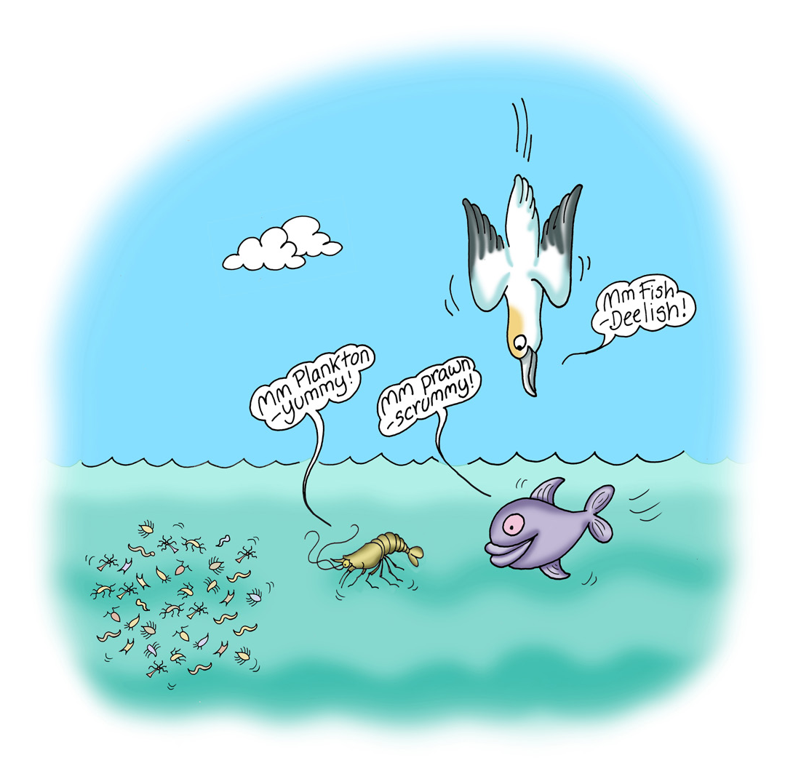
Introduction
All things are connected: the sun provides energy for plants to grow, plants feed herbivorous animals and they are fed upon by
carnivores. Life in the rock pool follows the same cycle and a simple way to illustrate this is play a food web game on the beach.

In the marine environment, the sun provides energy not only for plants such as seaweeds and algae but to dinoflagellates, commonly known as plankton. Plankton is then eaten
ROCK
POOL
RUMMAGE
by smaller creatures such as prawns, shrimps and shellfish which in turn are eaten by larger predators such as fish which are then eaten by urchins, birds and ultimately humans.

So a basic rock pool food web/chain would look something like this:

Sun > plankton & plants > shrimps, prawns, shellfish > crabs, young or small fish (blennies), starfish > large fish, birds (oyster catcher, gull), seals > whales.

Humans eat several elements of a rock pool food web including prawns, shrimps,
shellfish and larger fish.

Before the visit
Carry out the preparatory activities suggested for Rock Pool Rummage to
familiarise children with life in a rock pool.

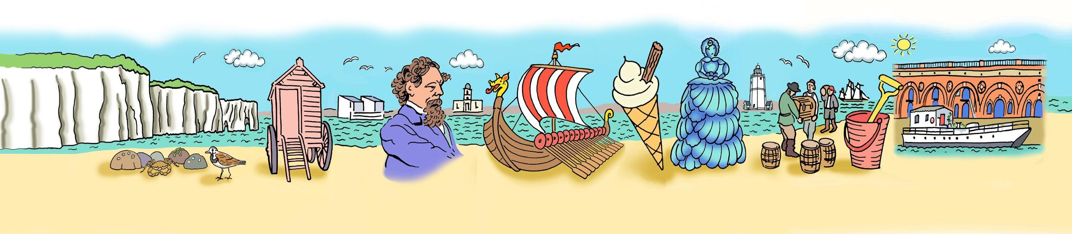

During the visit
After exploring the rock pools arrange the children into a large circle. The marine food chain/web will then be built in the middle of the circle. You will then need lots of willing volunteers to be:
- Plankton
- Plants
- Shrimps
- Shellfish
- Fish
- Starfish
- Sea urchins
- Birds
- Humans
Arrange children in a triangular pattern in the middle of the circle with plankton and plants as the base (6-8), shrimps and shellfish (4-5) as the next layer, fish, starfish and urchins (3) next followed by birds & fish (2) and finally humans (1). Children remaining on the outside represent the sun. Scattered around the inside of the circle there should be half a dozen crabs feeding on rock pool detritus. To illustrate the
connectivity of the marine food web you should link everyone together. You can either use a ball of string to do this, running the string around the sun and then connecting to the plankton and plants and so on until the human is reached or you can have the sun children hold hands and link the pyramid of creatures with string.

After the visit
You can apply this information to any of the activities suggested as part of Rock Pool Rummage to enhance displays.

Resources
String if you wish to link your food web together. Alternatively, you can use coats or sweatshirts!

