Suitable locations: Margate Main Sands and Ramsgate

Holiday History

KS
1&2

Learning Outcomes
After taking part in this activity children will understand the popularity of the English seaside holiday from the Victorian period onwards. They will also have an insight into changing beach fashions and how holidaymakers enjoyed themselves in the past.
HISTORY

Introduction
During the 18th century bathing in the sea and drinking seawater became a fashionable cure for a variety of diseases. Visitors from London arrived on boats to stay in Thanet, initially for sea water cures but then as a place for socialising, leisure and pleasure.

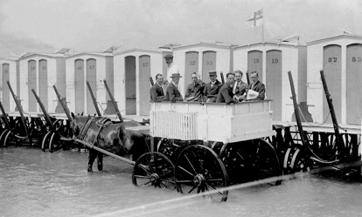
A common sight in the early days of seaside recreation was the wheeled bathing machine, designed to protect the bather’s modesty. Benjamin Beale of Margate invented the
SUITABLE
ANY
TIDE
earliest bathing machine. It
was a complicated
construction with an
enormous canvas canopy that
extended beyond the machine
to over the area of water in
which the bathers swam,
thus keeping the bather
safe from ‘the gaze of idle
or vulgar curiosity.’

With the advent of the railways and cheap fares, holidays to the seaside became available to all, which meant the resorts of Thanet grew in popularity and size. Visitors came not just for the fresh sea air but entertainment as well. Walking along the promenade was popular and many seaside resorts extended this walk by building a pier from the end of which you could catch a steamer. On the beach, tourists could enjoy a Punch and Judy show, musical entertainers and donkey rides. Margate was the first resort to popularise donkey rides on the beach in the early 1800s.

There is a timeline in the Introduction section, with key dates in Thanet’s history.
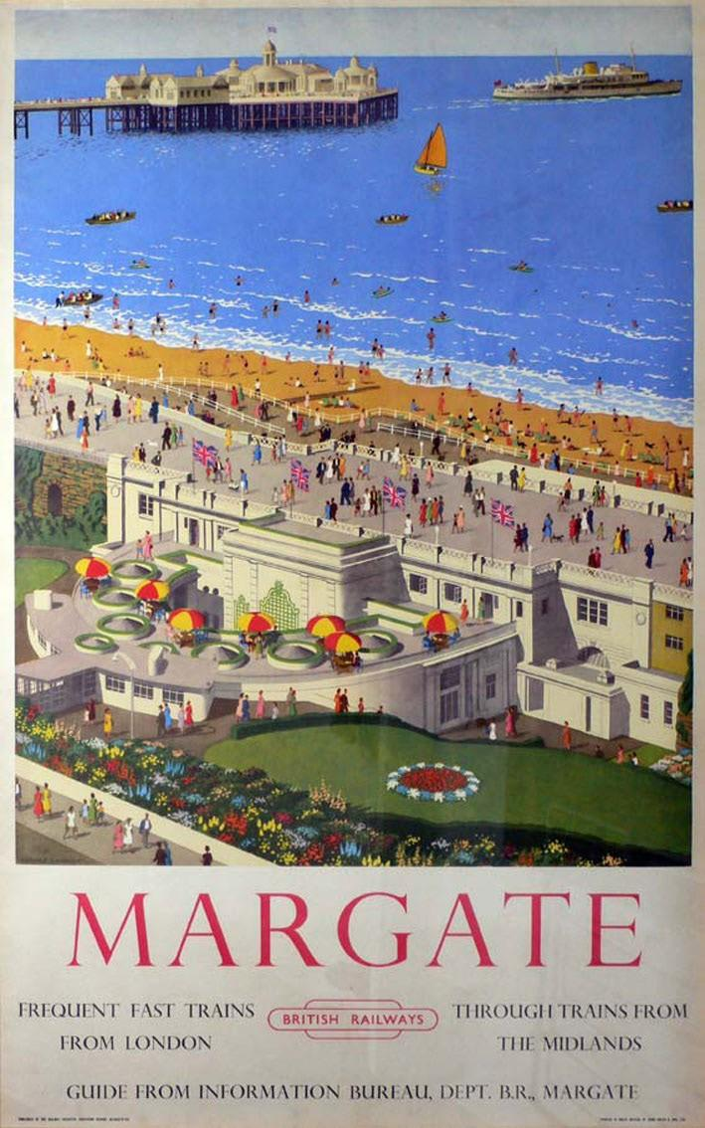
Seaside fashions have of course changed over the years and a look at early photographs makes you wonder if the heat of summer could really be enjoyed when wearing full Edwardian costume!

Resource 11 provides a selection of photographs from the Mick Tywman Archive showing holidaymakers enjoying themselves long ago.

Margate Museum offers educational visits about seaside history, visit www.margatemuseum.org
for more information.

Before the visit
Look at the photographs in Holiday History Resource 11, Historic Photos and discuss the differences and similarities between holidays past and present. How do children think the holidaymakers in the photographs felt? Do they look like they are having fun?

During the visit
To add a little something extra to your fun-packed day at the beach you might like to recreate your own group photograph similar to those illustrated in Resource 11, Holiday History, Historic Photos.

After the visit
Create a display of your contemporary group photos alongside the Edwardian images highlighting the differences and similarities. Choose one of the children from a photograph, think about who they might be and where they could have come from and then, using a postcard design from the Wish You Were Here Activity write a postcard home describing what they might have done on the beach.

Resources
Resource 11: Holiday History, Historic Photographs Resource 12: Holiday History, Historic Brochures
You could also use Resource 7: Blank Postcards, for this Activity.

