Suitable locations: Margate Main Sands, Joss Bay, Ramsgate, Minnnis Bay

Changing Coasts

KS2
Learning Outcomes
After taking part in this activity children will understand how the coastline of Thanet has been shaped and changed by the sea and other natural forces and how those changes have been managed and will be managed for the future.
GEOG

Introduction
Thanet was once an island and is still referred to as ‘The Isle of Thanet’. The west and south-west coast were separated from the mainland by the Wantsum Channel. Over time this gradually silted up, land was reclaimed and Thanet ceased to be an island. The north, east and south coasts of Thanet were, and still are, subjected to the full force of the sea. Wave action eroded the soft chalk creating the cliffs that you see today.
SUITABLE
ANY
TIDE
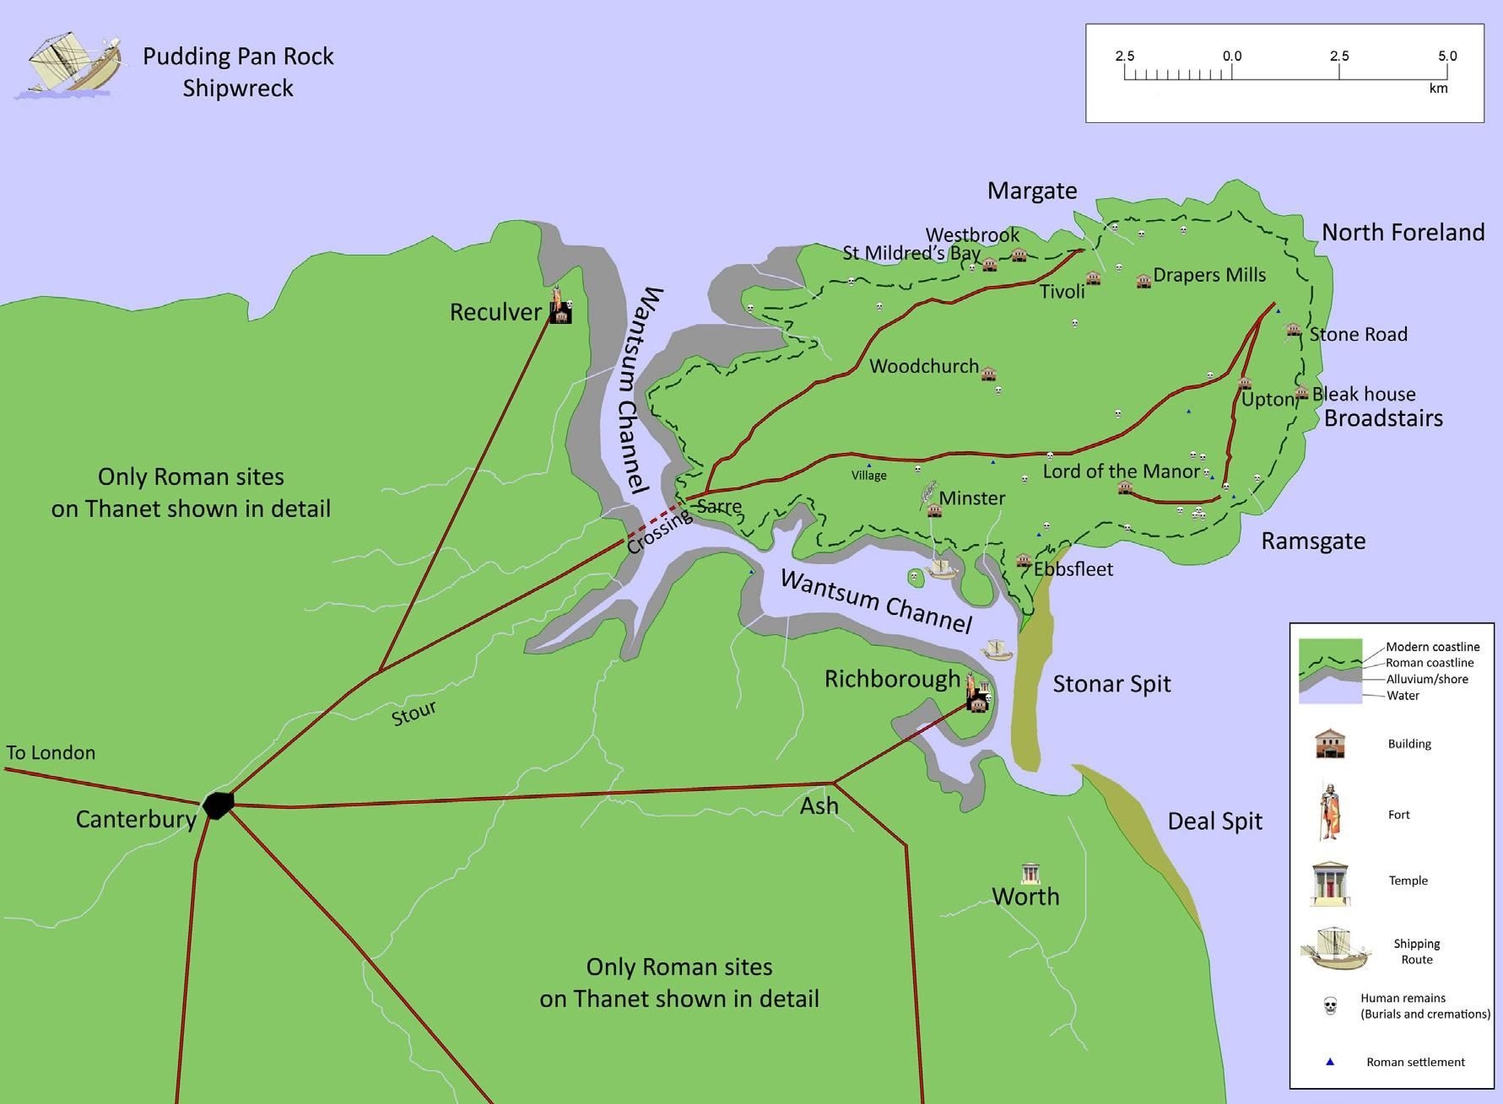
Reproduced with permission of Gerald Moody, author of Isle of Thanet.

Erosion is on-going and much of the Thanet coastline is currently protected by man- made defences in an effort to halt or slow this process. But in some places the cliffs are undefended and the natural process of erosion continues.

Erosion can happen under any conditions, but its rate tends to increase when waves are powerful and water levels are high - for instance during storms or in high winds. Eroded material is broken down, washed out to sea and is then deposited on the shore. The sand that makes the Thanet beaches is a product of erosion elsewhere along the coast.

Cliff erosion produces lots of interesting features such as caves, arches, stacks and wave-cut platforms. For an explanation of how erosion works and how these features are produced see Resource 13 and 14, Changing Coasts.

Before the visit
Introduce children to the concept of cliff erosion using the diagrams and photographs in Resources. Why do children think that along some parts of the Thanet coast the cliffs have been protected by sea walls and defences?

During the visit
Look out for examples of cliff erosion and coastal features like those outlined in Resources 13 and 14. The wave-cut platform is where you will find the rock pools for the Rock Pool Rummage activity. It’s worth getting the children to pause and think whilst rock pooling that they are standing where cliffs once stood.

After the visit
Produce a wall display featuring the basic coastal erosion features. You could also include illustrations/photographs of any fossils you find.

Resources
Resource 13: Changing Coasts, Coastal Erosion Explained Resource 14: Changing Coasts, Cliff Formations

