Suitable locations: Margate Main Sands, Joss Bay, Ramsgate, Minnnis Bay

Resource 16: What’s The Ship?

A basic guide to some of the larger ships you might see from the beach during your visit.

KS 1

GEOG

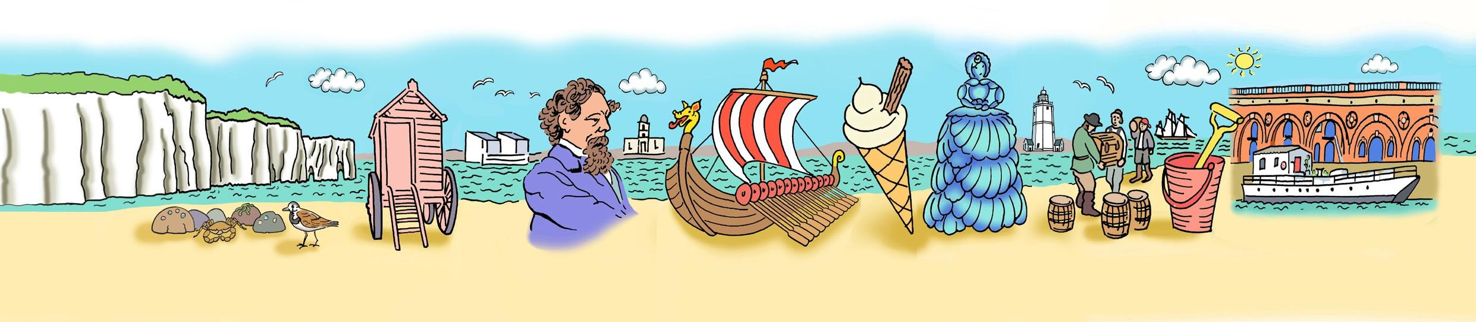
Passenger ship
IDENTIFICATION
SHEET

Tanker

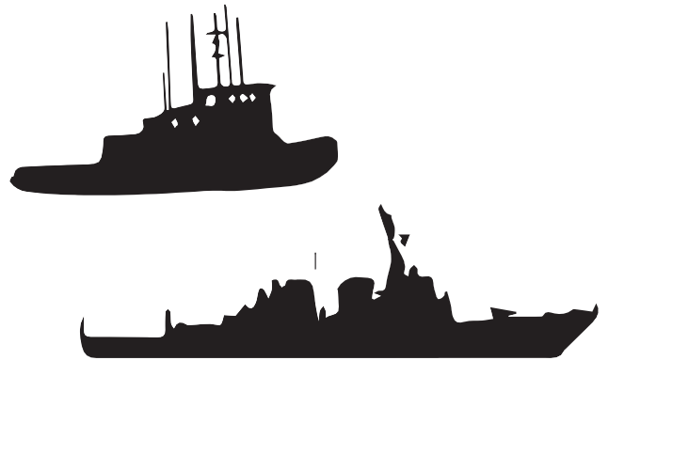
Tug

Fishing Boat

Navy Ship

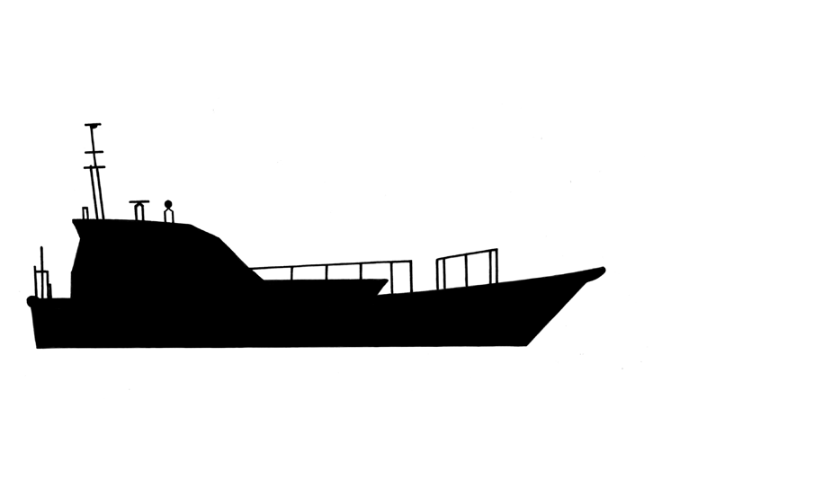

Yacht Pilot Boat

