Suitable locations: Margate Main Sands, Joss Bay, Ramsgate, Minnis Bay

What’s That Ship?

KS 1
Learning Outcomes
After taking part in this activity children will be able to identify some of the different types of ship that pass through the busy English Channel.
GEOG

Maritime traffic around Thanet’s Coast
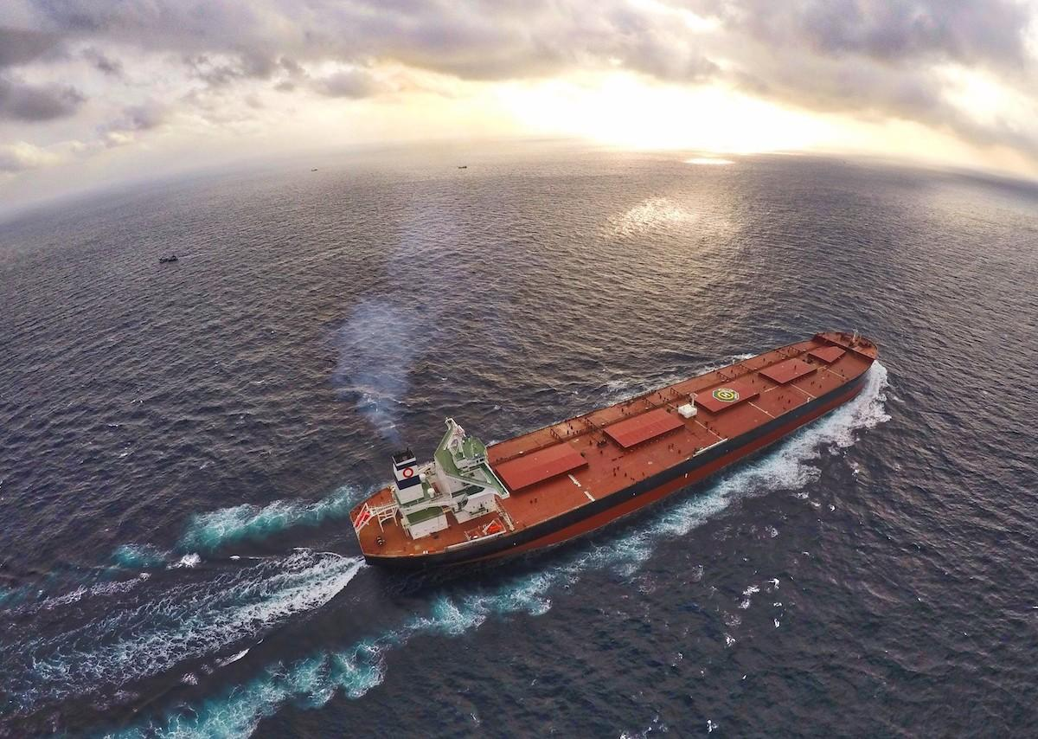
The sea off Thanet’s Coast is one of the busiest shipping lanes in the world, with over 500 ship movements each day. It links the North Sea and the English Channel with the Atlantic Ocean and is used by maritime transport and shipping as well as fishing boats and coastal pleasure craft.
SUITABLE
ANY
TIDE

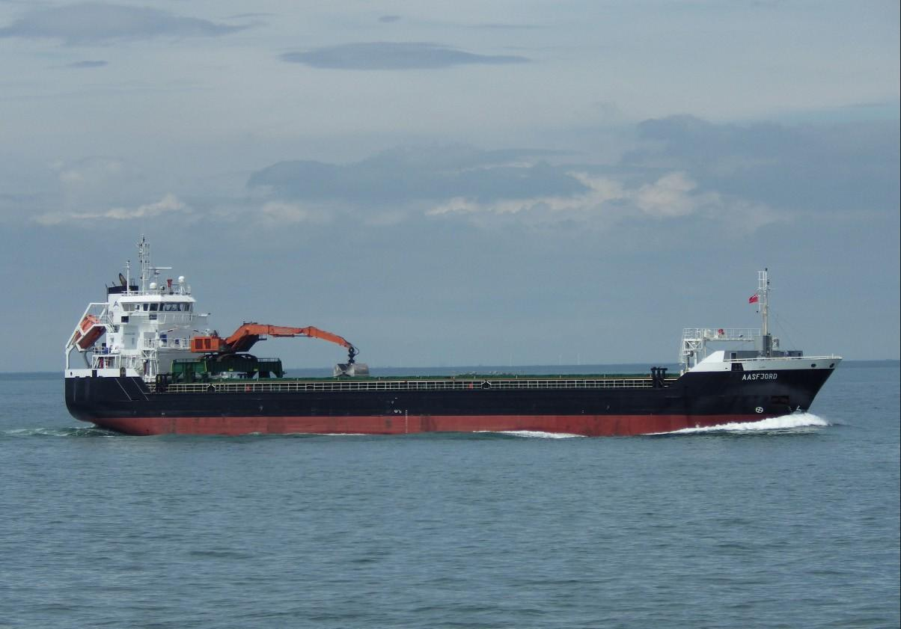
Thanet’s coastline is dangerous and there have been many shipwrecks over the centuries. It is dangerous because of currents along the coastline and there are shifting and unstable sand banks offshore, such as the notorious Goodwin Sands, off the coast near Ramsgate. Beacons and lights have been lit on
the coast for centuries, to help ships navigate safely around Thanet’s seas. The area around Joss Bay and North Foreland was particularly dangerous and there are records of a fire being lit at North Foreland in 1499.

The first real lighthouse at Joss Bay was built in 1636 but was replaced by the current building in 1691. North Foreland lighthouse was the last lighthouse to be automated in the UK. It is now two private holiday cottages.

Ramsgate is England’s only Royal Harbour. It is a busy working port as well as a resort. There are cross-Channel freight ferries and smaller working craft such as pilot boats and Royal National Lifeboat Association boats as well as many pleasure craft.

Many ships seen around Thanet’s coast are travelling to the Port of London. They hire local pilot ships to help them navigate their route through the Thames Estuary. The lifeboat stations at Ramsgate and Margate are some of the oldest stations in the UK. Visit: www.rnli.org for more information.

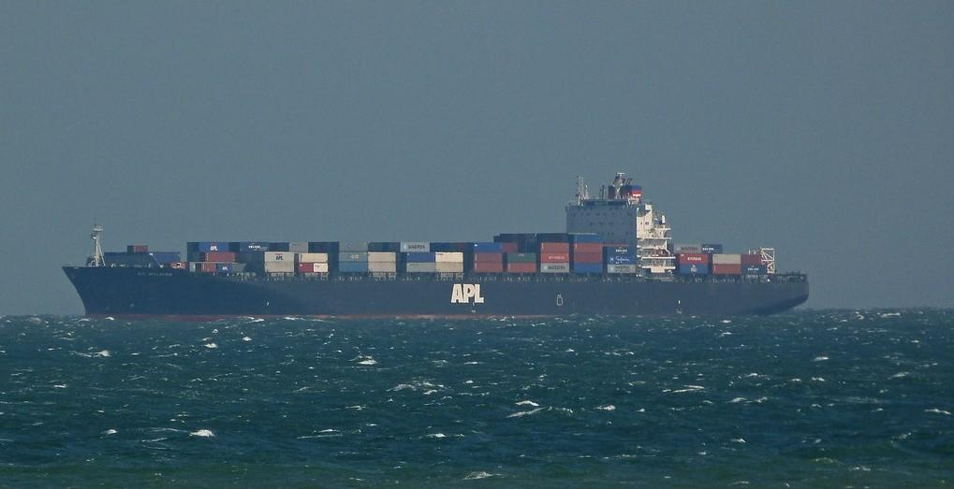
The development of the Automatic Identification System (AIS) has made maritime traffic management much safer. You can see live vessel movements around the UK on this website: www.shipais.com It’s a fascinating website, constantly recording the freight and passenger ships traveling around the Thanet coast via a live Automatic Identification System (AIS).

Before the visit
Make children aware of the fact that the English Channel is busy with ships from all over the world.
Show some images of the larger types of vessels such as container ships and tankers. Visit
www.shipais.com in the classroom shortly before your visit to Thanet to get an idea of the shipping in the area. Large international ships often anchor off the Thanet Coast, waiting for permission to enter the Port of London.

During the visit
Use Resource 16, What’s That Ship to help identify any ships you see out at sea. You
can do this whilst having your lunch or snack.

After the visit
Talk with the children about the shipping that travels around Thanet’s coast, where it has come from, now and in the past.

Produce a plan showing the range of different ships that travel around Thanet, where they come from and what they are carrying.

Resources
Resource 16: What’s That Ship?

