Create your own rock pool scene in a box

KS
1&2
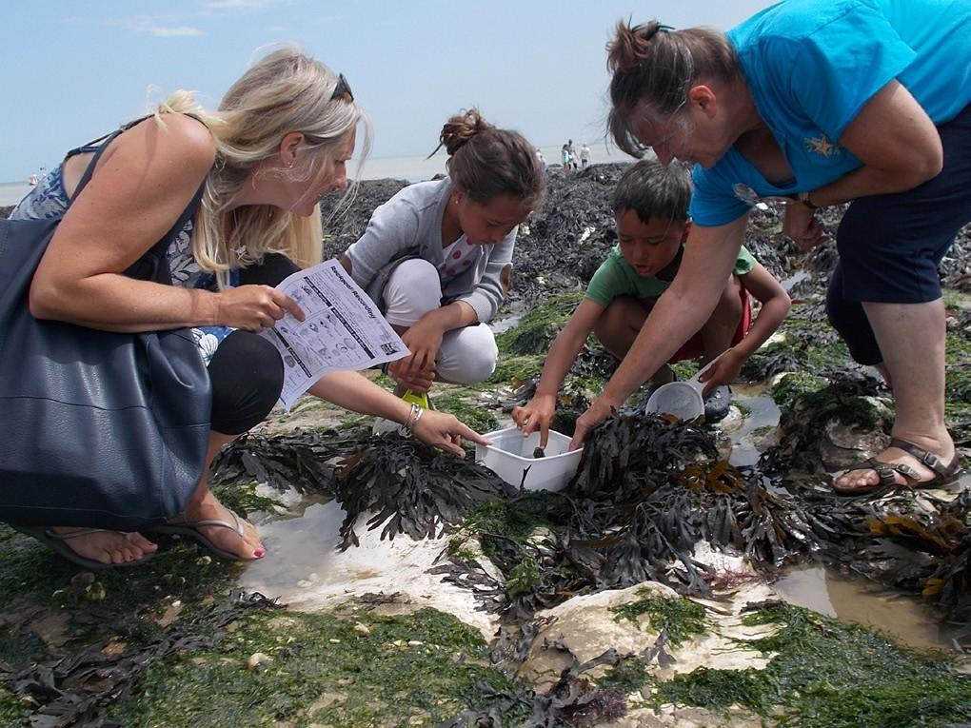
You will need:
- A shoe box or slightly larger
- Copies of the rock pool creatures from Resource 3.

SCIENCE
- Crayons and paint
- Tape
- Thread
- Scissors
- Optional: pipe cleaners for seaweed, glitter for bubbles, thin card to glue the images on to.

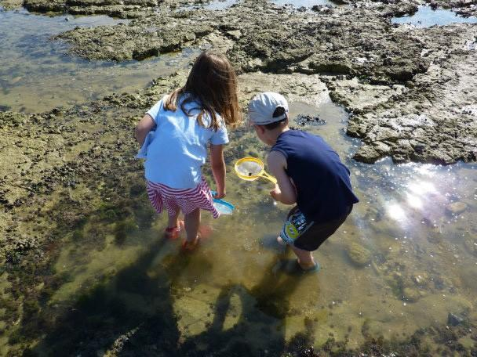
How to make your diorama:
- The box is the stage for your rock pool scene.
- Decorate the inside of the box, painting the sides blue for the sea and the base yellow. You could add seashells found on the beach, small pebbles and dried seaweed.
- You could also paint some seaweed shapes on the sides.
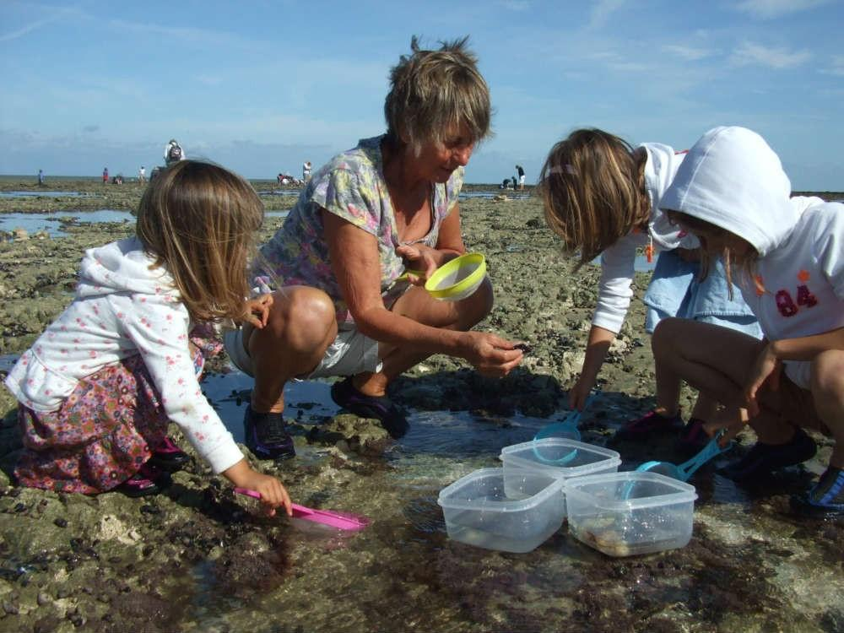
- Print out the rock pool creatures from the Resource 3 (you may need to stick
these to card to stiffen them)
- Colour the creatures and then hang them with cotton thread from the top of the box.

Card 1
I have tube feet that act like suckers; I can lay two million eggs in two hours; I am spiny skinned; I eat shellfish by opening them with my feet; I have five arms and if one gets damaged I can regrow it.
Card 2
I have eyes on the ends of stalks; I can run sideways quickly; I carry my eggs under my tail flap; I have eight legs and two claws; I shed my hard shell as I grow.
Card 3
I have long antennae which help me to spot danger; I shed my skin every two weeks in the summer; I have a transparent body; I escape from predators by moving backwards quickly.
Card 4
I am an animal but look like a flower; I have 200 tentacles that sting; when the tide is out I look like a small blob of jelly; I catch small fish and shrimps which I place whole into my mouth.
Card 5
I have a strong foot which uses suction to keep me stuck tightly to rocks; I only move about 1m from my home base, or ‘home scary,’ to eat seaweed; I eat with my rasping tongue.

Answers

- Starfish
- Crab
- Prawn
- Sea anemone
- Limpet

