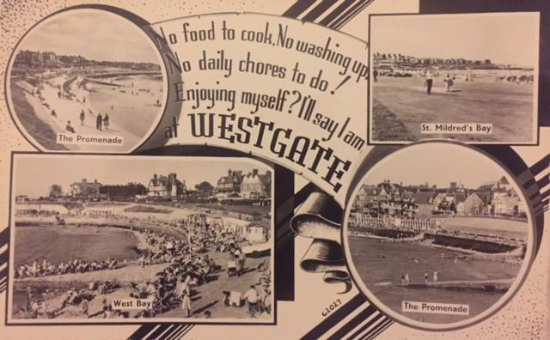
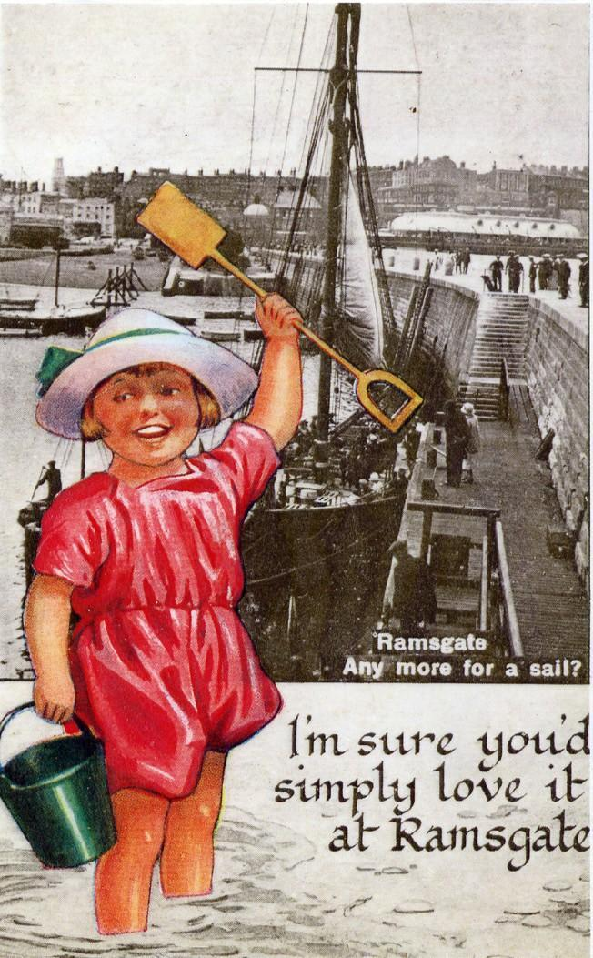
Here are some design ideas for postcards. There are also some template designs for you to photocopy and use to add your own photographs or drawings. Children could also come up with their own ideas for a novelty seaside postcard.
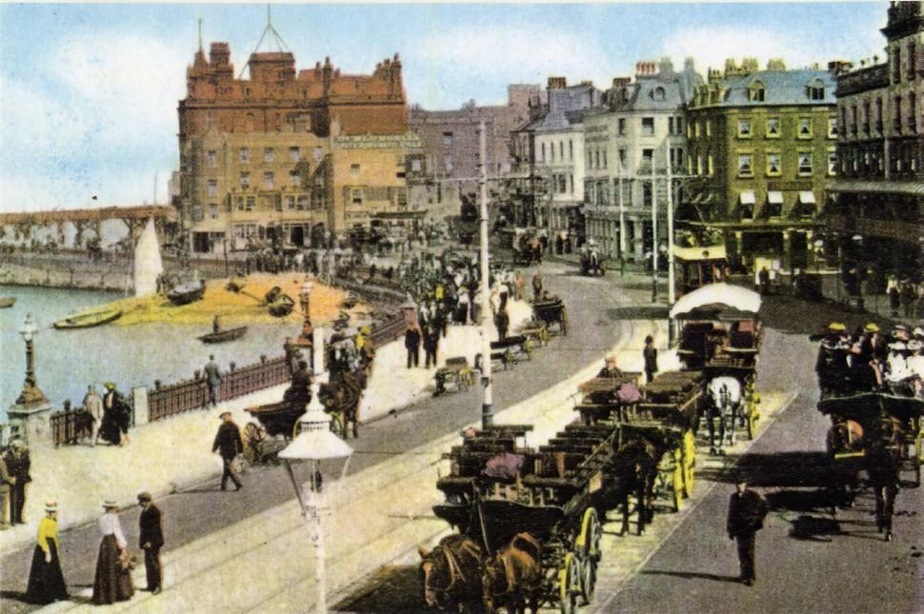

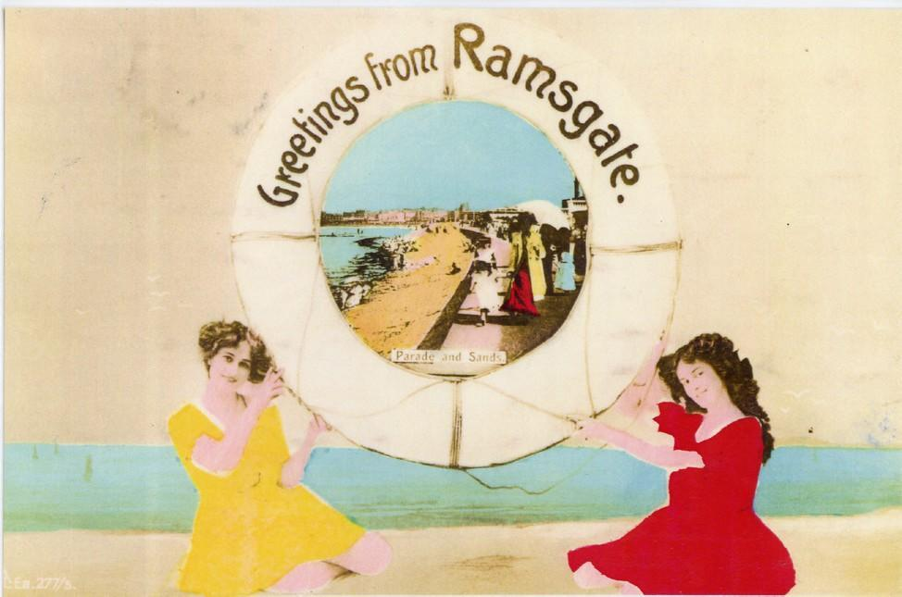
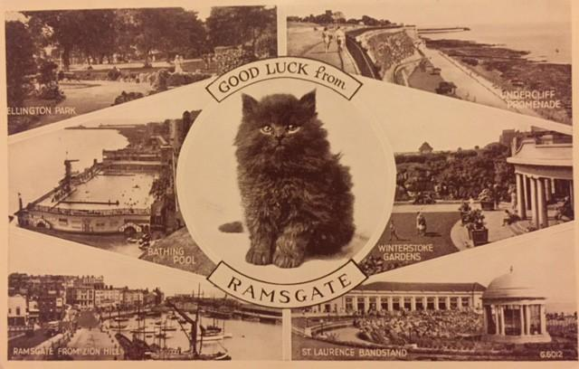
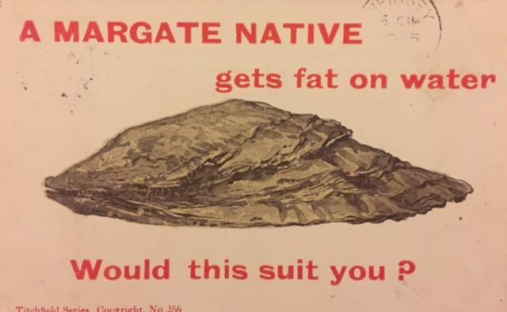
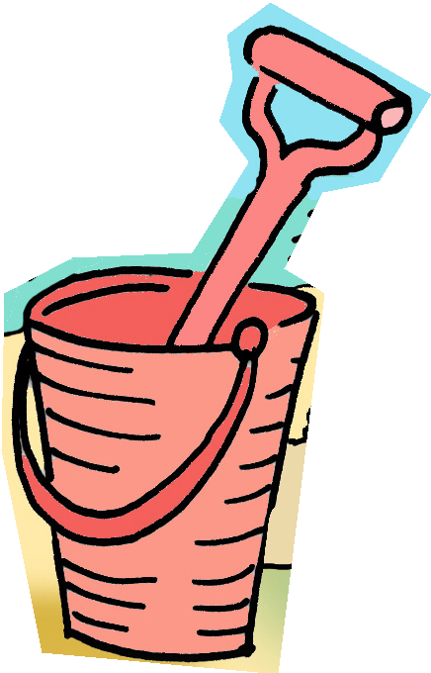
Resource 7: Blank Postcards

Greetings from Margate

Greetings from Margate
Resource 7: Blank Postcards

Greetings from Joss Bay

Greetings from Joss Bay
Resource 7: Blank Postcards

Greetings from Ramsgate

Greetings from Ramsgate
Resource 7: Blank Postcards

Greetings from Minnis Bay

Greetings from Minnis Bay
Resource 8: The Big Colouring-In Resource

The Big Colouring-In Resource
A collection of Thanet-inspired images for colouring-in, displays, postcards and other creative projects for fun and learning at the seaside.

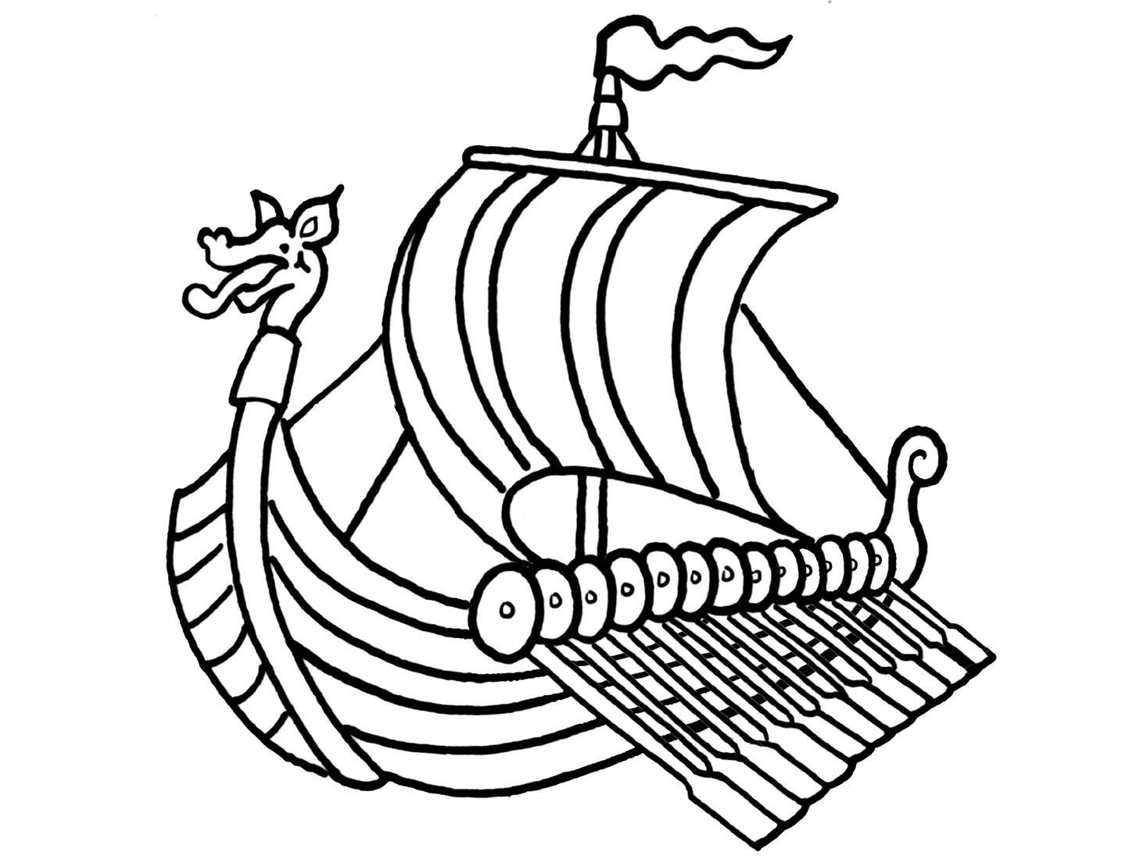

Viking Ship

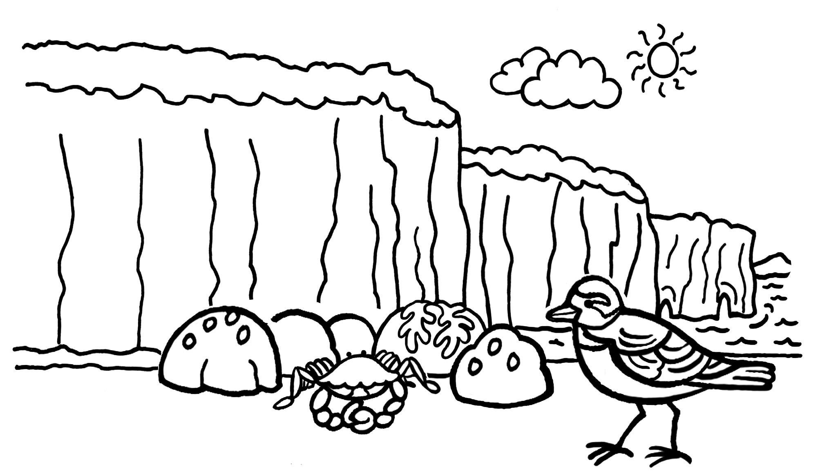

Turnstone and crab on beach

Resource 8: The Big Colouring-In Resource

Charles Dickens

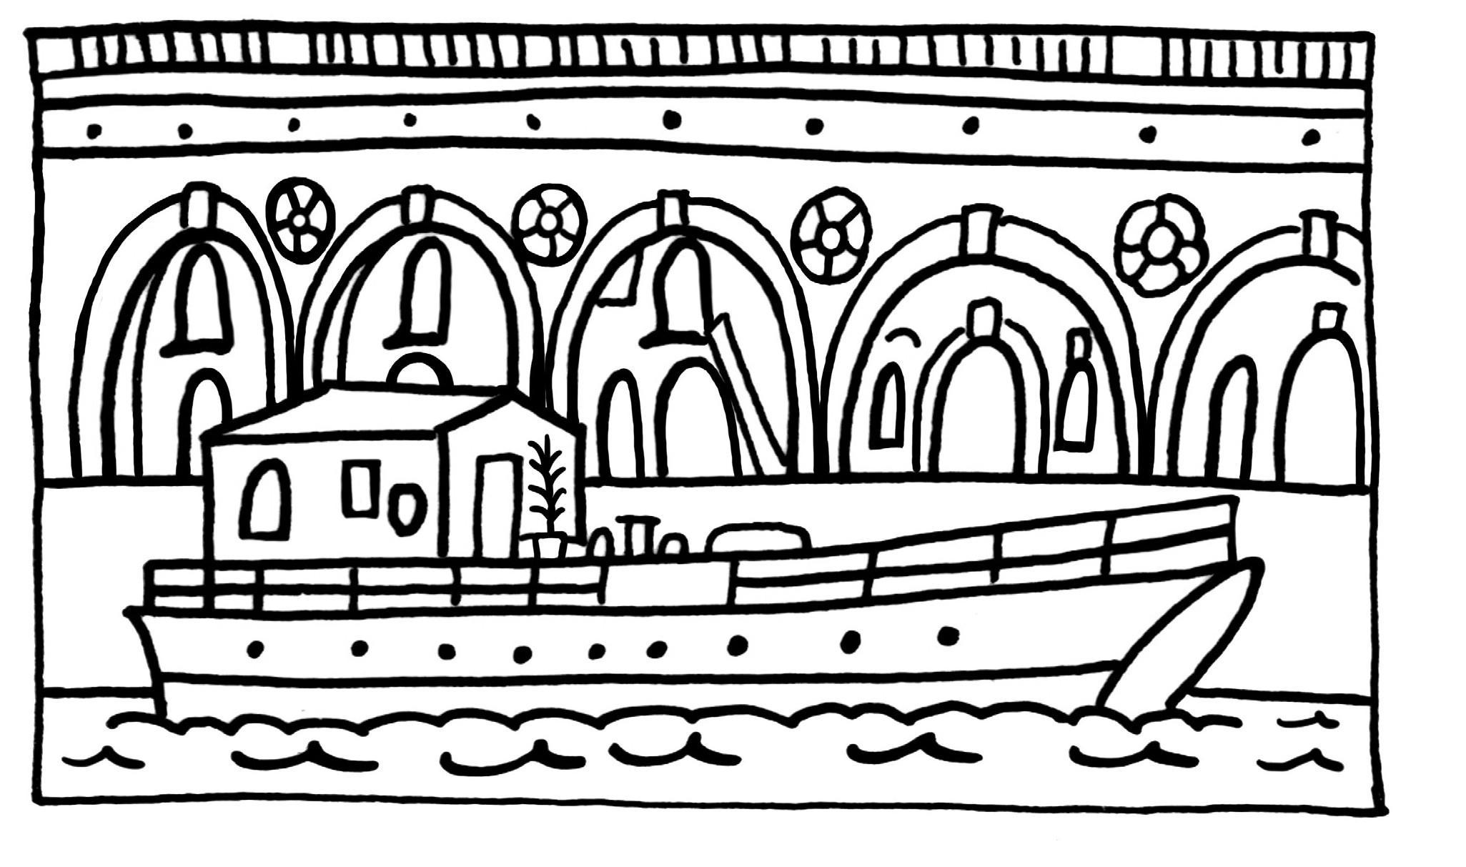

Ramsgate Arches

Ramsgate Arches

Resource 8: The Big Colouring-In Resource

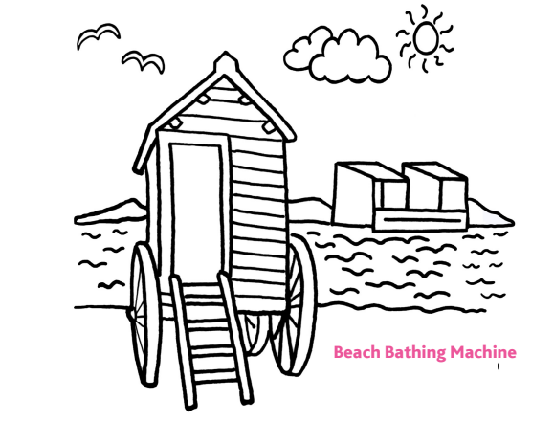

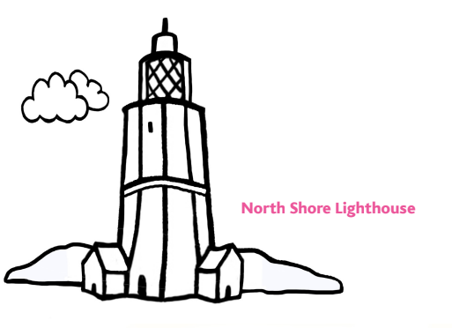

Resource 8: The Big Colouring-In Resource

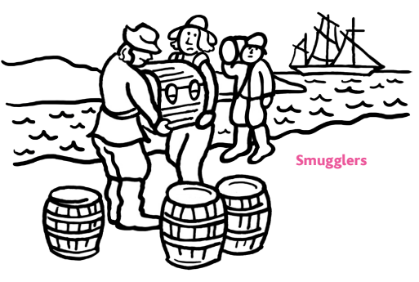
Art

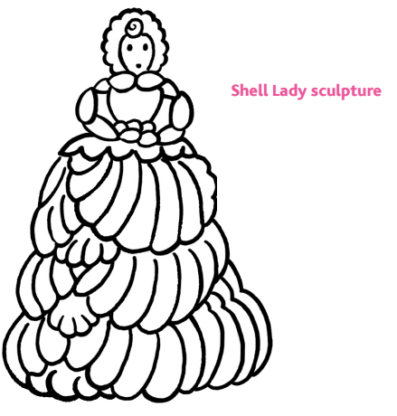

Resource 8: The Big Colouring-In Resource
Art

