Suitable locations: Margate Main Sands, Joss Bay, Ramsgate, Minnis Bay

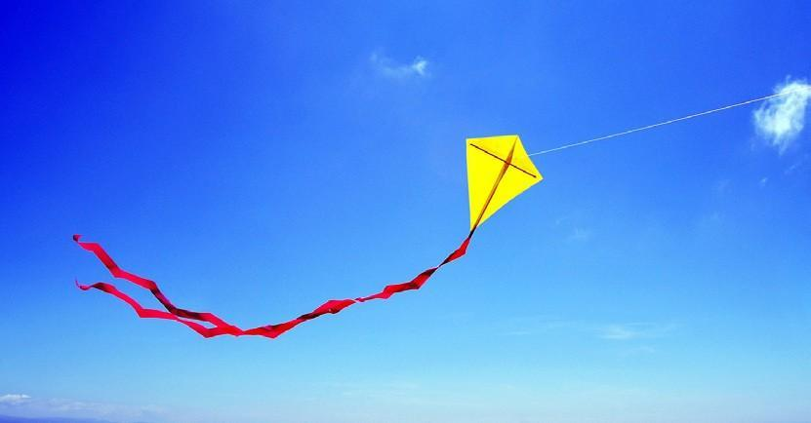
Learning Outcomes
After taking part in this activity children will understand the technical requirements necessary to build and fly a kite and they will also have learned and applied their own design skills.

Introduction
Flying a kite is great fun, but the experience is even more rewarding if it’s a kite you have made yourself.

The small paper kite is easy to make and based on a kite made by children in India to celebrate the Hindu festival of Makar Sankranti.

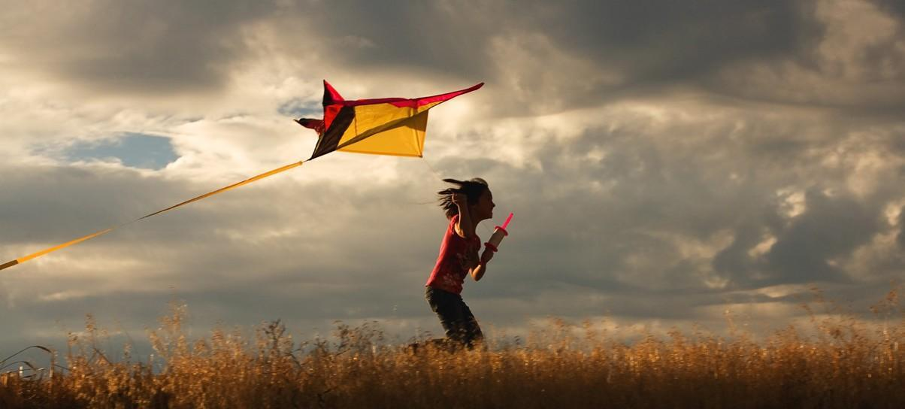
Before the visit
Use the instructions in Resource 9 to build and decorate your kites.

During the visit
Fly your kite!

Remember to be careful where you fly your kite. Beware of overhead lines, buildings
and other beach users. Have fun!

After the visit
Use your kites to make a beach scene wall display.

Discuss what it was like flying your kites and what methods you used to get your kite
airborne.

Resources
Resource 9: Go Fly A Kite, Instructions for making a kite.

