Suitable locations: Margate Main Sands, Joss Bay, Ramsgate, Minnis Bay

Resource 10: Maritime Myths and Local Legends,
Five Audio Stories

Here are five audio files featuring the following stories

KS 1 & 2

Hermit Wants a Shell KS1
Hermit, like all hermit crabs lives in a sea shell to protect his soft body. But what happens when he outgrows his seashell home? Unable to venture out from beneath a protective rock Hermit sings a song in the hope that a helpful sea creature will find him a shell. Find out who appears in his rock pool and which one of the creatures is successful in the shell search.

ENGLISH
Written by storyteller, Steve Manning.

Sun, Moon and Water KS1 & KS2
A myth from Africa explaining why the sun and moon climbed into the sky and also why the tides are affected by the moon.

Why the Sea is Salty KS1 & KS2
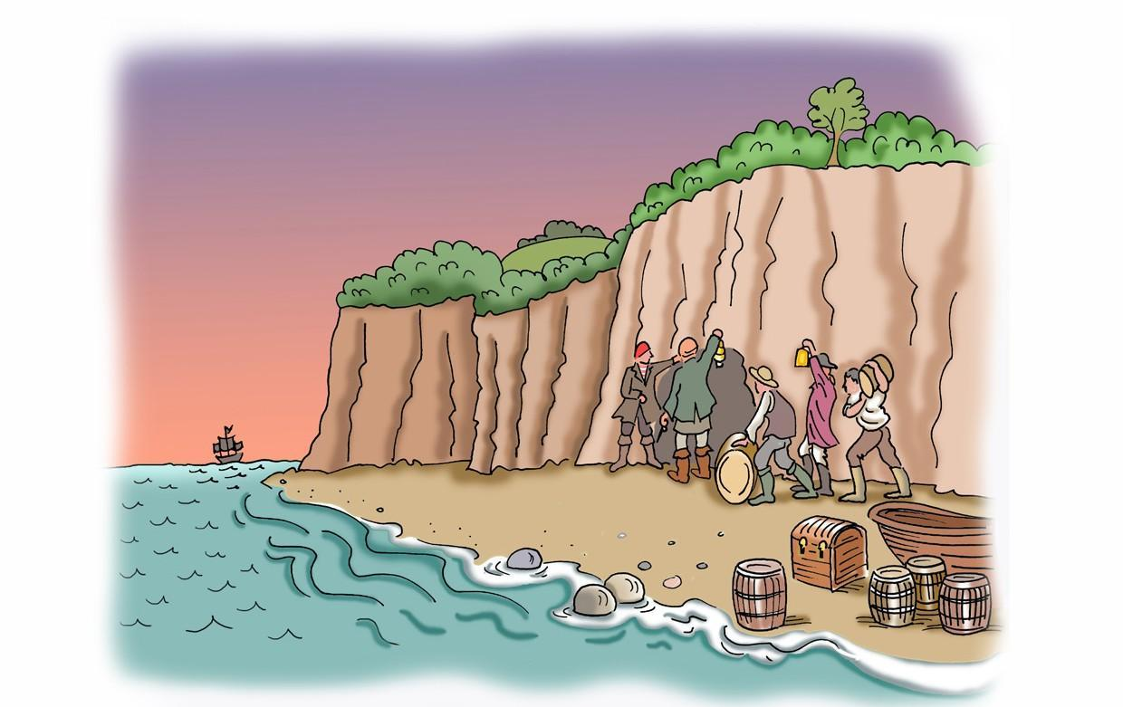
A traditional tale, found throughout Europe, explaining why the sea is salty. It features a magical, salt-grinding hand mill, a greedy sea captain and a wrecked ship.

Joss Snelling the Smuggler KS2
This story tells the tale of the infamous Battle of Botany Bay, Broadstairs, when Joss and his gang of smugglers were ambushed by the Excisemen. Few facts are known about this event so the story imagines the events that led to the skirmish and Joss’s escape.
Written by storyteller Steve Manning.

The Smuggler’s Leap KS2
This rhyming tale has been adapted from a story of the same name which appears in ‘The Ingoldsby Legends’, written by Kent cleric and novelist Richard Barham in the 19th century.
The tale tells the story of the feud between Smuggler Bill and Exciseman Gill which
ends in an epic chase, the intervention of the Devil and a doomed plummet into a chalk pit!
Adapted and rewritten by storyteller Steve Manning.

