Suitable locations: Margate Main Sands, Joss Bay, Ramsgate, Minnis Bay

Resource 15: If Chalk Could Talk - Common Chalk Fossils

Some of the most common fossils on Thanet.
Micraster and Echinopsis are the most common sea urchin fossils found on the Thanet Coast. We also have Belemnite fossils which are the backbone of a squid like animals. You can also find bits of broken shell (Inoceramus) and even the occasional rare ammonite!

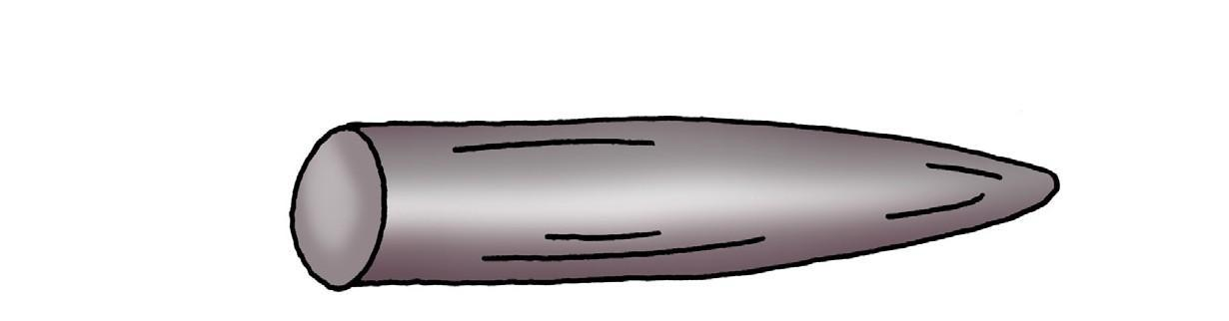
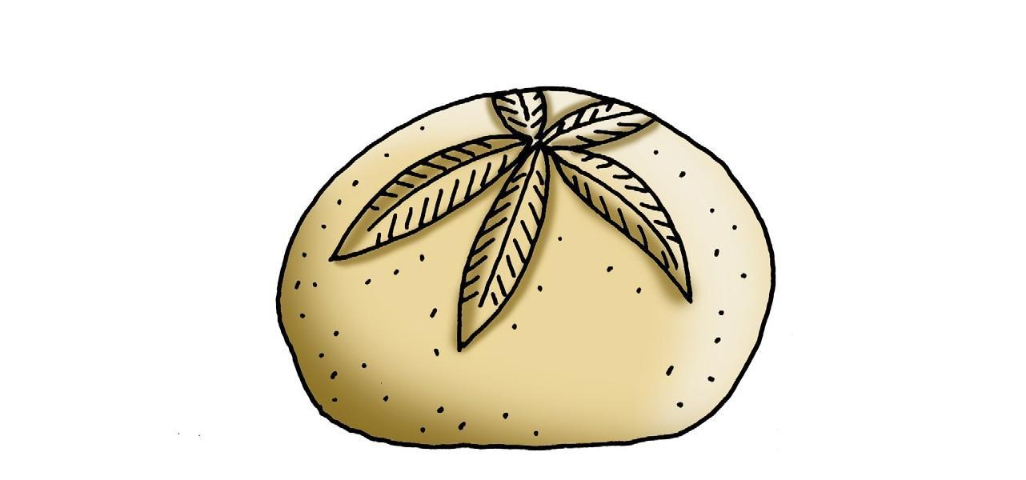

Belemnite

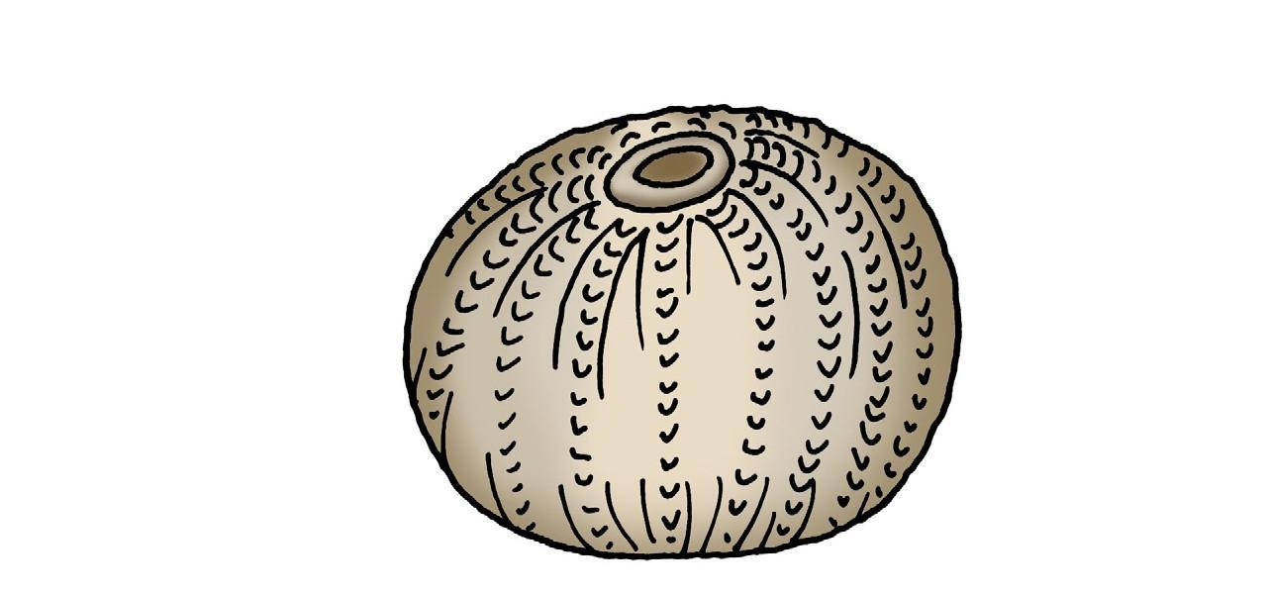

Micraster

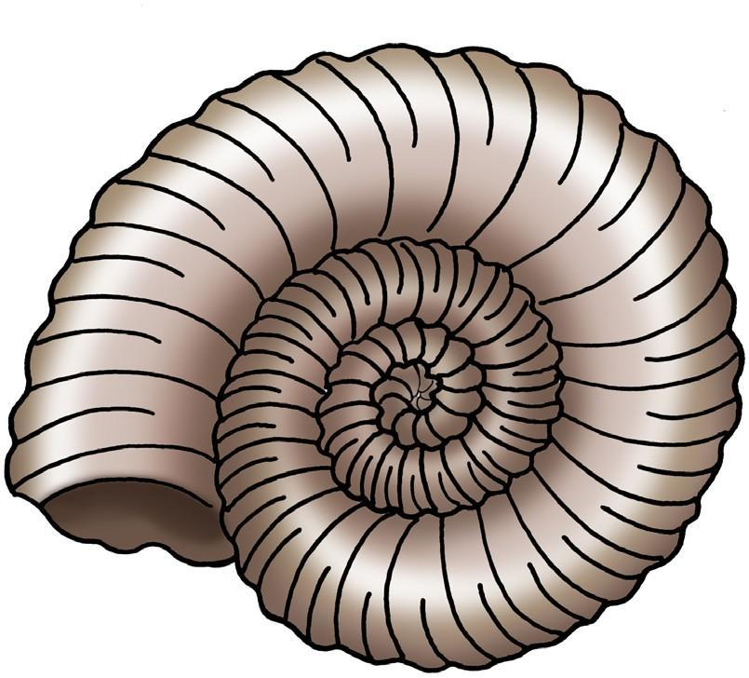

Echinopsis

Ammonite

