This Activities Section contains 12 Activities that can be enjoyed by schools and youth groups on Thanet’s beaches. Each Activity also has information about its learning outcomes, its relevance to the National Curriculum and ideas for work before and after a beach visit. The Activities are supported by resource materials which are presented in the Resources Section.

The 12 Activities are: Page

Rock Pool Rummage 2-4
Looking for animals and plants that live in rock pools.
This Activity is supported by Resources 1, 2 and 3.

World Wide Watery Web 5-6
A food chain game to play on the beach.
This Activity needs string, or you could use coats.

Beach I Spy 7-8
A game looking for natural materials left by the tide.
This Activity is supported by Resource 4.

Strictly Beach Art 9-10
Creating beach art inspired by Thanet’s history and wildlife.
This Activity is supported by Resource 5.

Try a Turner 11-12
Artistic techniques for painting sky and clouds, as done by JMW Turner.
This Activity requires paint, brushes and paper.

Wish You Were Here 13-14
Looking at historic seaside postcards and designing new ones. This Activity is supported by Resources 6, 7 and 8.

Go Fly A Kite 15
Technical know-how for making a small paper kite.
This Activity is supported by Resource 9.

Maritime Myths and Local Legends 16-17
Five audio stories for KS1 and KS2 about wildlife and smugglers
This Activity is supported by Resource 10.

Holiday History 18-19
Investigating seaside holidays from Victorian times to the present day.
This Activity is supported by Resources 11 and 12.

Changing Coasts 20-21
Past and present coastal erosion on Thanet’s cliffs and beaches.
This Activity is supported by Resources 13 and 14.

If Chalk Could Talk 22-23
Thanet’s chalk is full of marine fossils including sea urchins and echinoids.
This Activity is supported by Resource 15.

What’s That Ship? 24-25
Identifying ships and boats on the English Channel and Thames Estuary.
This Resource is supported by Resource 16.

Suitable locations: Margate Main Sands, Joss Bay and Minnis Bay

Rock Pool Rummage

KS
1&2
Learning Outcomes
After taking part in this activity children will understand that rock pools provide a safe habitat at low tide for marine plants and animals and that they support a

SCIENCE
diversity of creatures dependent upon each other. They will also be able to identify a selection of rock pool creatures.

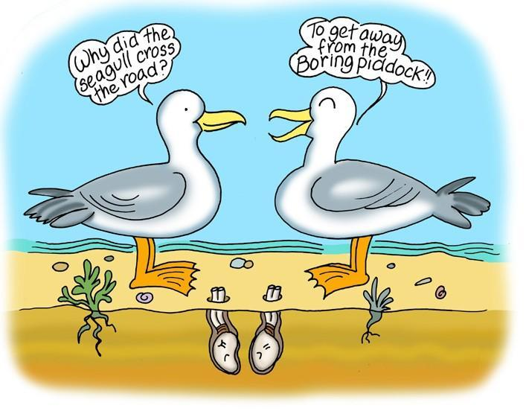
Introduction
The Thanet Coast is a Marine Protected Area that includes a Marine Conservation Zone. The coastal rocky reefs and rock pools are rich in plant and animal life and can be easily accessed and explored at low tide. In many of the pools and crevices you will often find prawns, hermit crabs and small fish taking shelter until the tide rises.

LOW
TIDE
ACTIVITY
ONLY

One local resident is the boring piddock named not because of its dull nature but because it bores holes in the chalk!

Guidelines
- Dry and calm weather is ideal for rockpooling as this will keep the surface of a rock pool still, making it easier to see what lies beneath.
- Pools closest to the sea edge are better, but take care as the chalk reef may be more fragile and more easily damaged here.
- Start by seeing what’s swimming under the surface. You might see small fish such as a goby or blenny. Prawns and shrimps are also common inhabitants
of rock pools. They move very quickly and often swim backwards when you least expect it.
- At the bottom of rock pools you might see a starfish or its skinny, spiny relative,
the brittlestar.
- Try turning over seaweed where you might find the white swirls of tube worms
such as tubeworms, which are offically called Spirobis.
- Look at rocks to see if you can see keel worms, or
gently look beneath to see if green shore crabs or
edible crabs, which often look like pebbles, are living there.
Always remember to replace them back gently, the right way round!
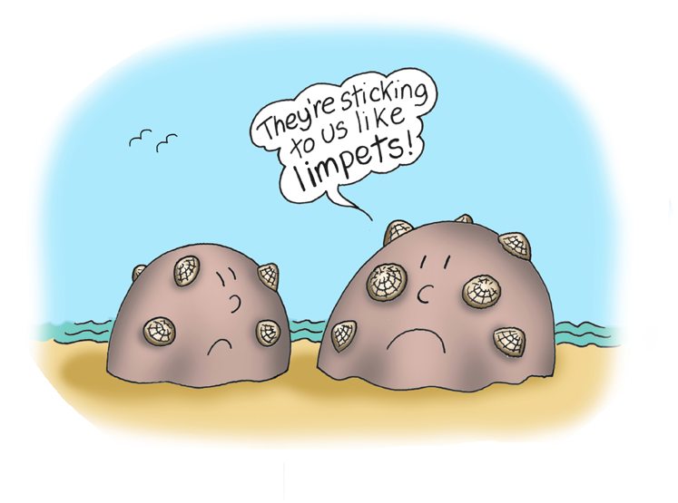
- To catch rock pool creatures place a bucket in the water and see what swims in or push it gently through the water to scoop them up. Remember to let them go again where you found them after
a short time.
- Take time to explore the crevices between rocks where you may find periwinkle shells, mussels and dogwhelks.
- On more exposed bits of rock you may find
limpets and barnacles.

Before the visit
Look at pictures of seashore and rockpool life or watch a brief video such as https://www.youtube.com/watch?v=CczvL4hgiFQ which shows common species such as shrimps, hermit crabs and fish such as blenny and wrasse.
Julia Donaldson’s book Sharing the Shell is also a good introduction.

Children will need to understand that:
- Rockpools are left behind as the tide falls
- Creatures living in rock pools are waiting until the tide rises again

KS1 children can listen to ‘Hermit’s Shell’ story (Resource 10) as well as looking at pictures of rock pool life to prepare them for their visit.

Remember - always check the tide times before you visit as part of the risk assessment, as it is best to view rock pools over an out-going (receding) tide, close to low tide.

During the visit
Remember – always check the tide times to ensure you will not be cut off by an incoming tide
- Divide children into small, manageable groups.
- Prepare children with a brief safety talk, warning them that the rocks can be slippery and to take care when exploring.
- Remind them too that creatures living in the pools should be treated gently and if any are caught they must be returned to their original pool.
- Turn over rocks and seaweed carefully and gently replace them in the same position, otherwise they will have left creatures’ homes ‘upside down’.
- Only take away empty shells, but it’s best to leave most of them for wildlife to use.
- Use Resource 3, Identification Sheet to help recognise
plants and animals living in the rock pool.
- When the excitement of searching the pools is over, examine

the creatures that have been caught and ask children what differences they can spot between creatures, how do they move, what do children think they might eat and do they have a favourite rock pool creature.
- Encourage children to draw the rock pool creatures.

After the visit
You can use information gathered during the visit to do some of the following:
- Use Resource 2, Rock Pool Rummage, Sea Creature Cards, to remind children about what creatures they found
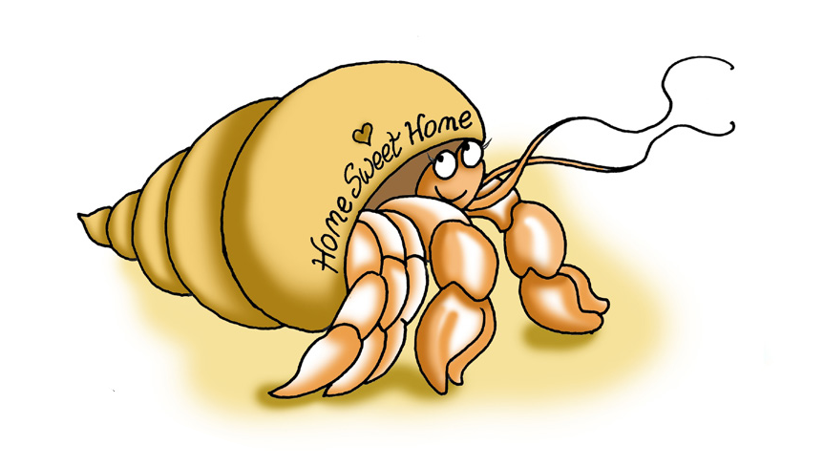
- Create a rock pool food web wall display
- Create a diorama using Resource 1, Rock Pool Rummage, Diorama
- Write an account, or produce a storyboard, of a day in the life of a hermit crab or other rock pool animal.
- Write a postcard home about your rock-pooling day (see Resource 6 for postcard designs)

Equipment needed
For a successful rock-pooling expedition you will need the following:
- Buckets
- Shallow plastic trays
- Identification sheets
- Shoes that are suitable for walking in water and on rocks are useful for this activity!

Using a net is not a good idea, as many rock pool creatures are small and delicate and being tangled in a net can damage them.

Resources
Resource 1: Rock Pool Rummage, Diorama
Resource 2: Rock Pool Rummage, Sea Creature Cards
Resource 3: Rock Pool Rummage, Identification Sheet
Resources 6 and 10: Blank Postcards and Five Audio Stories, may also be useful for Rock Pool Rummage Activity.

Suitable locations: Margate Main Sands, Joss Bay, Ramsgate, Minnis Bay

World Wide Watery Web

Learning Outcomes

KS2
After taking part in this activity children will understand that living things are all connected in some way and are dependent upon each other for their survival.

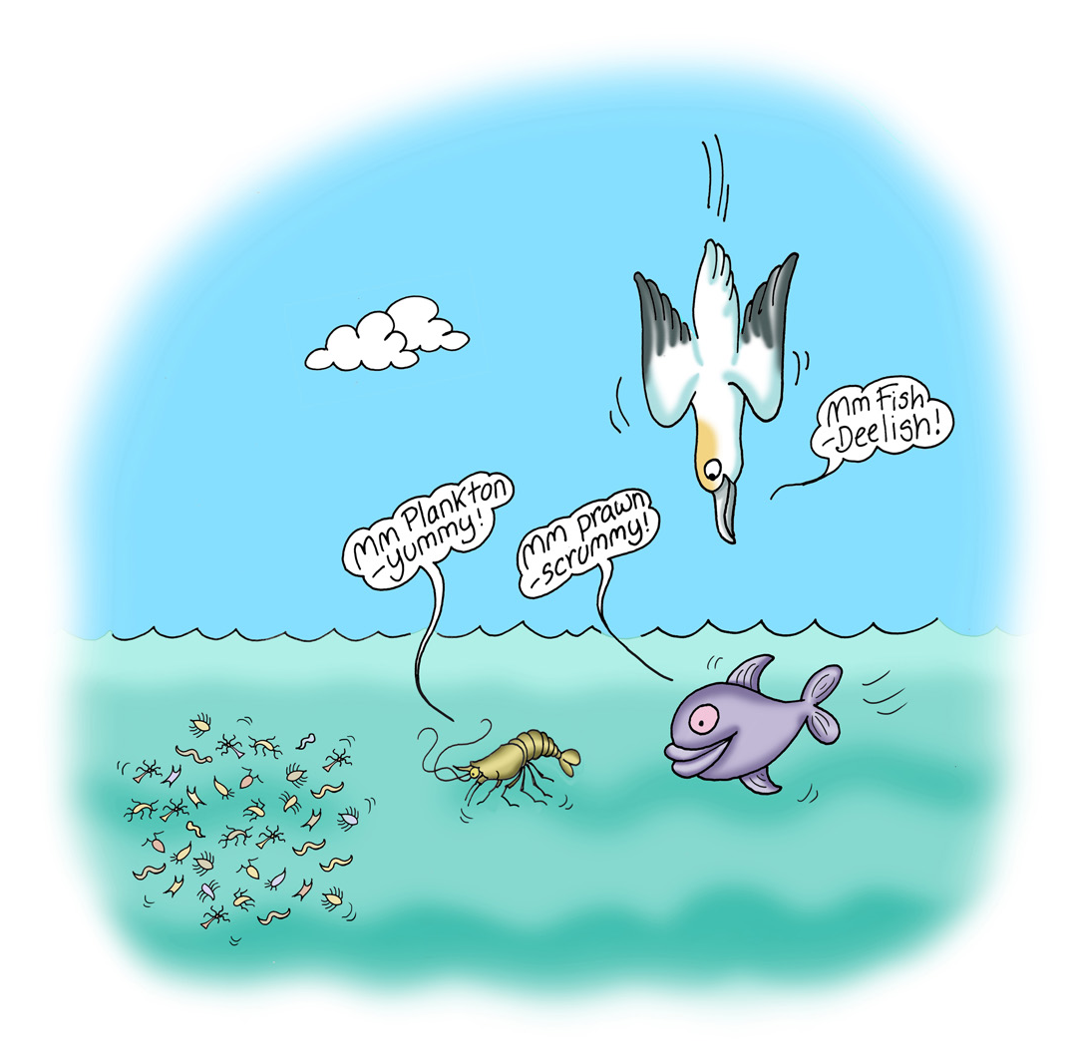
Introduction

SC I ENCE
All things are connected: the sun provides energy for plants to grow, plants feed herbivorous animals and they are fed upon by
carnivores. Life in the rock pool follows the same cycle and a simple way to illustrate this is play a food web game on the beach.

In the marine environment, the sun provides energy not only for plants such as seaweeds and algae but to dinoflagellates, commonly known as plankton. Plankton is then eaten

ROCK
POOL
RUMMAGE
by smaller creatures such as prawns, shrimps and shellfish which in turn are eaten by larger predators such as fish which are then eaten by urchins, birds and ultimately humans.

So a basic rock pool food web/chain would look something like this:

Sun > plankton & plants > shrimps, prawns, shellfish > crabs, young or small fish (blennies), starfish > large fish, birds (oyster catcher, gull), seals > whales.

Humans eat several elements of a rock pool food web including prawns, shrimps,
shellfish and larger fish.

Before the visit

Carry out the preparatory activities suggested for Rock Pool Rummage to familiarise

children with life in a rock pool.

During the visit
After exploring the rock pools arrange the children into a large circle. The marine food chain/web will then be built in the middle of the circle. You will then need lots of willing volunteers to be:
- Plankton
- Plants
- Shrimps
- Shellfish
- Fish
- Starfish
- Sea urchins
- Birds
- Humans
Arrange children in a triangular pattern in the middle of the circle with plankton and plants as the base (6-8), shrimps and shellfish (4-5) as the next layer, fish, starfish and urchins (3) next followed by birds & fish (2) and finally humans (1). Children remaining on the outside represent the sun. Scattered around the inside of the circle there should be half a dozen crabs feeding on rock pool detritus. To illustrate the
connectivity of the marine food web you should link everyone together. You can either use a ball of string to do this, running the string around the sun and then connecting to the plankton and plants and so on until the human is reached or you can have the sun children hold hands and link the pyramid of creatures with string.

After the visit
You can apply this information to any of the activities suggested as part of Rock Pool Rummage to enhance displays.

Resources
String if you wish to link your food web together. Alternatively, you can use coats or sweatshirts!

Suitable locations: Margate Main Sands, Joss Bay, Ramsgate, Minnis Bay

Beach I Spy

KS
1 & 2

Learning Outcomes
After taking part in this activity children will be able to identify some of the natural

SC I ENCE
flotsam found on the strand line and understand where it has come from.

Before the visit
A quick look at Resource 4, Beach I Spy will prepare children for this game of beach detectives. The natural flotsam cast up on a beach, particularly after a storm, gives some clues as to the creatures that live in the deeper oceans and what might have been carried vast distances by the sea.

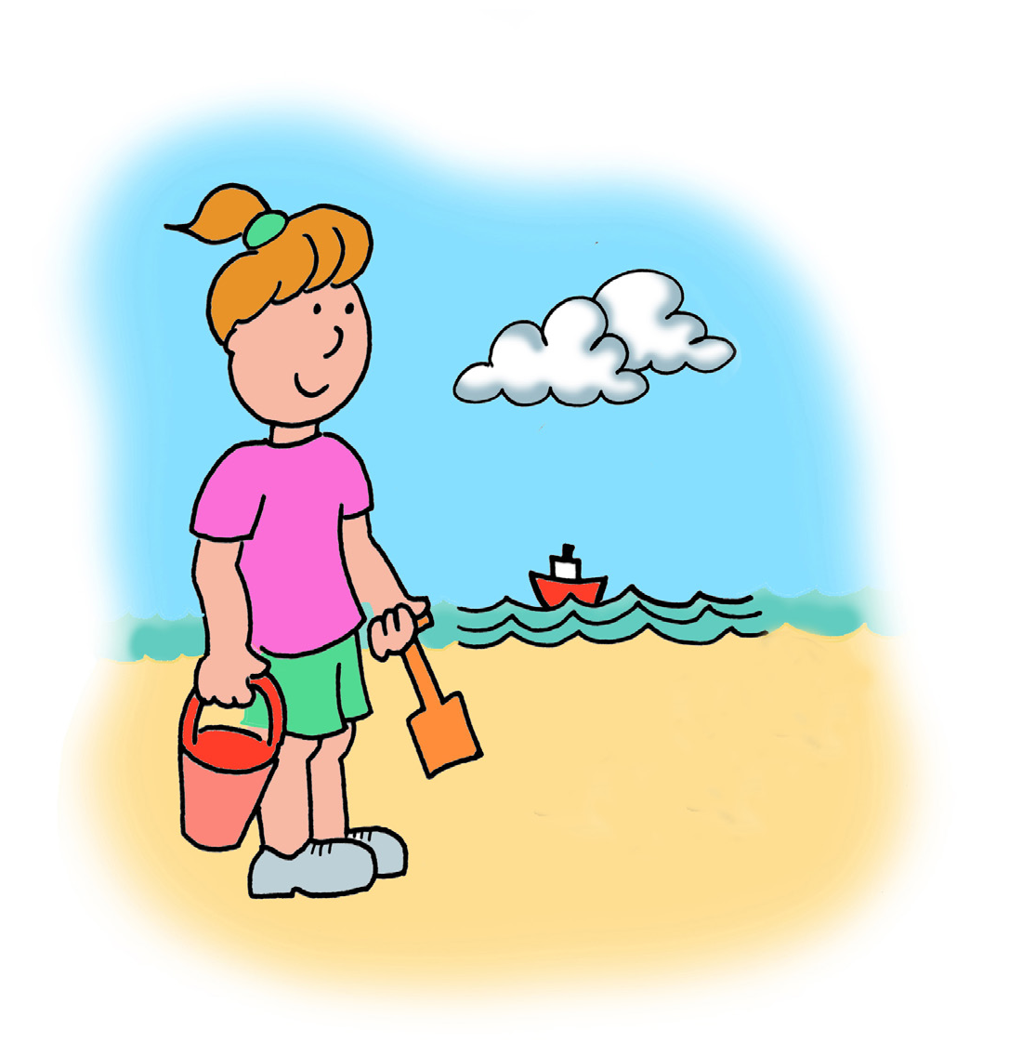
During the visit
Remember – always check the tide times to ensure you will not be cut off by an incoming tide.
- Be careful what you pick up on the beach
- Only take away empty shells
- The main beaches at Margate and Ramsgate are raked by tractors in the Summer months so you have to find a stretch of beach away from the main areas.

Armed with Resource 4, Beach I Spy
Identification Sheet, walk the tide line
and see what you can find. Remember, you’re
looking for natural things, not man-made rubbish.

Optional: You can always take a few litter sticks & bags to carry out a two-minute beach clean to remove any man-made litter at the same time, but stress to use the sticks and not hands for this.

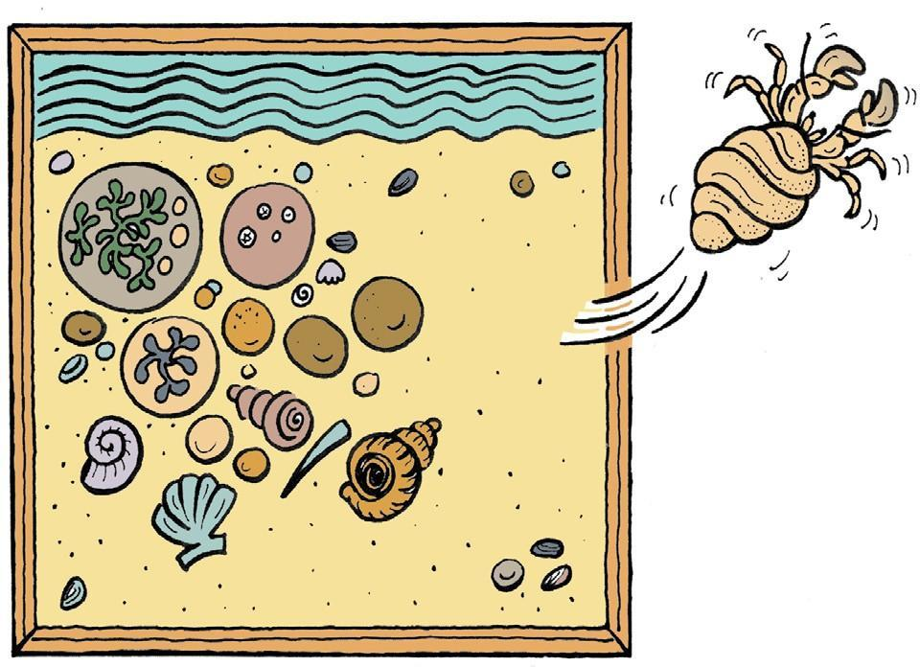
Marine memory game.
This is a fun way to remember what children have found on the beach. Here’s how to play it:
- Collect a dozen objects such as seaweed, shells, pebbles, feathers, mermaid’s purse from the beach
- Go through the collection and discuss each object
- Arrange the objects on the beach and give children one minute to concentrate on the objects and remember them
- After one minute tell children to turn their backs and remove one object
- Children turn around, can they guess which object has been removed and can they remember anything about it?

If you’re thinking about making the Rock Pool Diorama when back in school you might want to keep some small shells and bits of dried seaweed to use when decorating the Diorama.

After the visit
Use objects found on the beach as part of the Rock Pool Rummage display and/or set up a classroom version of the Marine Memory game.

Resources
Resource 4: Beach I Spy, Identification Sheet.

Suitable locations: Margate Main Sands, Joss Bay, Ramsgate, Minnis Bay

Strictly Beach Art

KS
1&2

Learning Outcomes
After taking part in this activity children will have a clearer understanding of shape and design and of some of the artistic styles used by people from Thanet’s past. The activity can also be used to reinforce learning from the Rock Pool Rummage activity.

ART

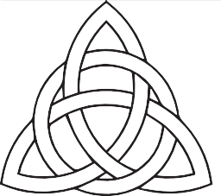
Before the visit
Show children examples of beach art using marks in the sand, pebbles and other objects found on the beach. A selection of images can be found in Resource 5, Strictly Beach Art.

LOW
TIDE
PREFERABLE

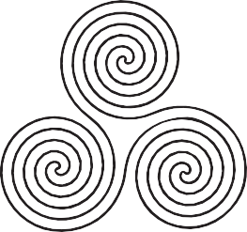
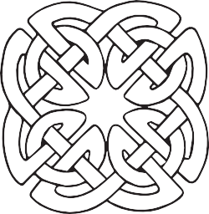
Your beach art design could be inspired by marine creatures that can be around our seas, or by the history of Thanet. For example, the Vikings came to Thanet
in the 9th century and brought their swirling
knotwork art with them.
Decide what designs you would like to make and draw some preparatory sketches. Think about what materials would work best for the designs, how big they should be and how many children could work on a pattern.

During the visit
Identify a good place to create your beach art. Slightly damper sand is preferable, particularly for figure and shape drawing, so you will need a falling tide. Scour the beach for pebbles, seaweed, shells, sticks to draw with and whatever else you might need. You could combine this with the Beach I Spy activity. Take the objects to your prepared area of sand and start building! Remember to sign and take a photograph of your finished works of art.

Sand figure drawing: a quick and effective method of producing drawings in the sand is draw round the outline of children lying on the sand. The outline can then be decorated with pebbles, sticks and weed to transform the figures into anything from mermaids to Viking warriors, sea creatures to fishermen.

After the visit
Use photographs to mount on a wall. Incorporate a photo of your beach art.
You could use photographs of beach art created during the visit as illustrations in the Wish You Were Here Activity, (Activity 6).

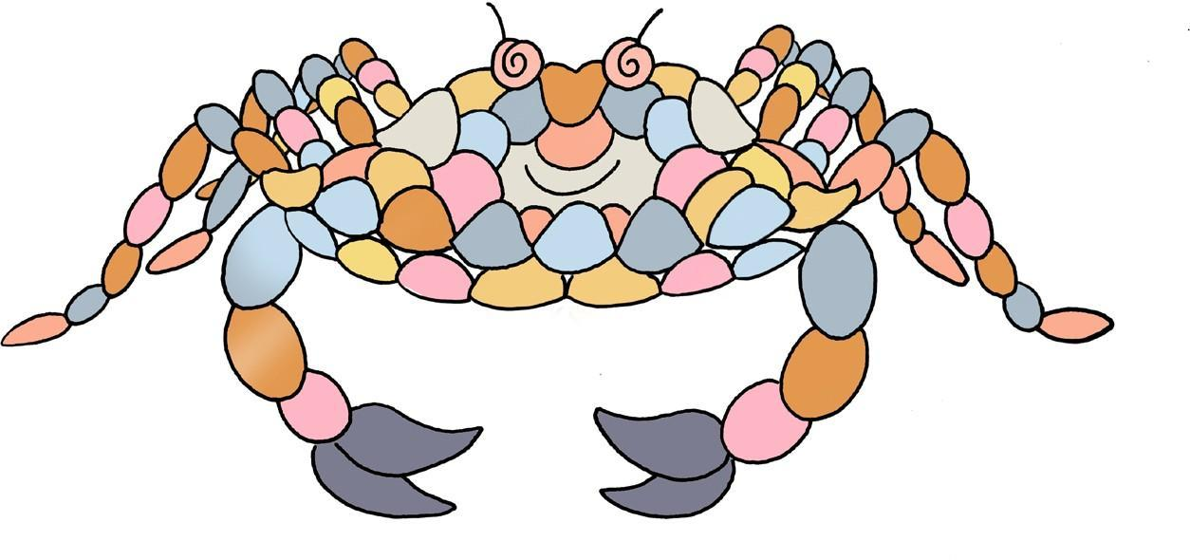
You will need
No specific equipment is needed
but the odd bucket and spade would be useful.

Resources
Resource 5: Strictly Beach Art
Ideas for Beach Art

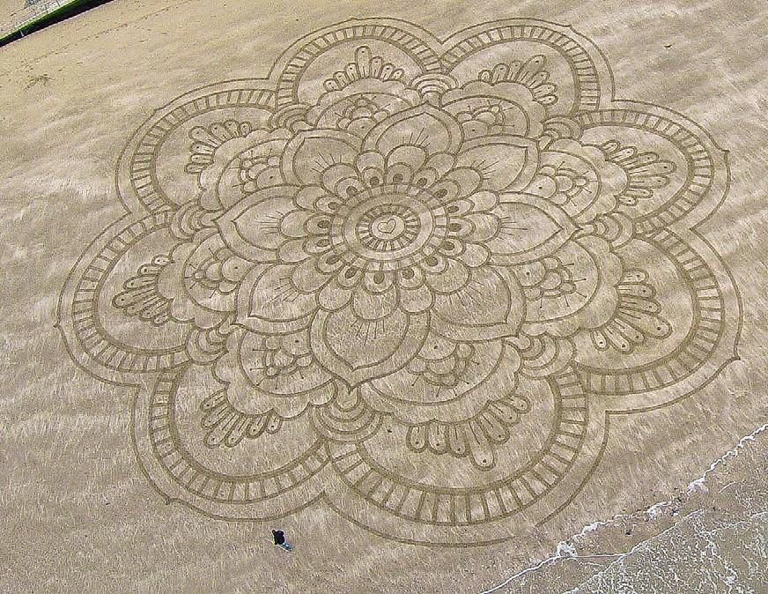
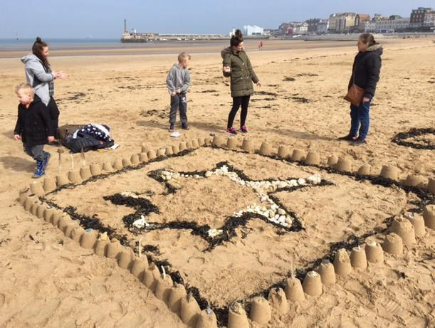

© Ross Andrews Art and Photography www.rossandrews.co.uk

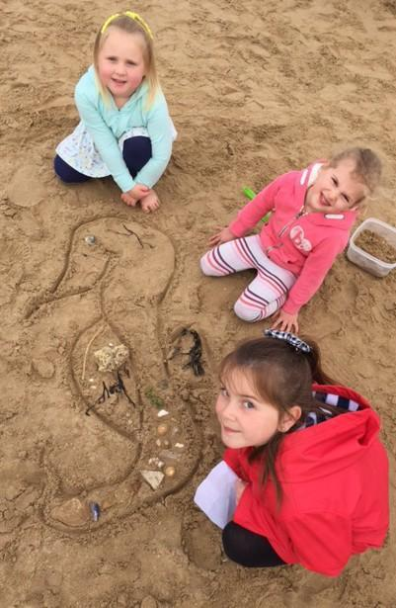
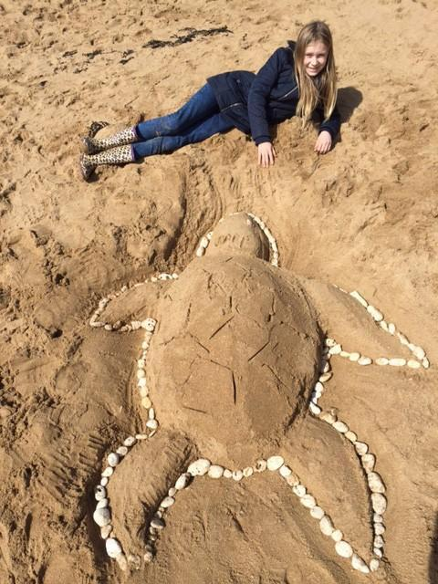
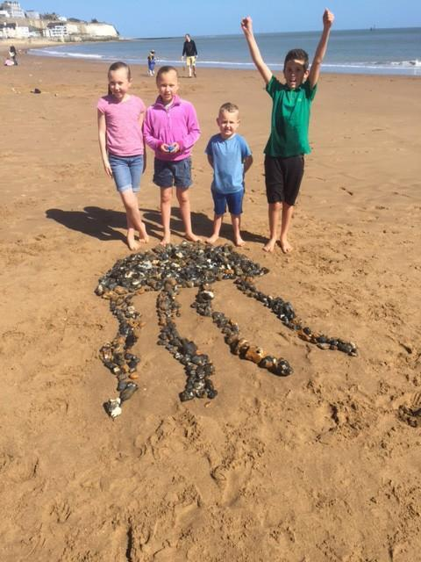

Suitable locations: Margate Main Sands, Joss Bay, Ramsgate, Minnis Bay

Try a Turner

KS2

Learning Outcomes
After taking part in this activity children will have an understanding of artistic techniques for depicting clouds and sky, together with a deeper appreciation of the art of JMW Turner.

ART

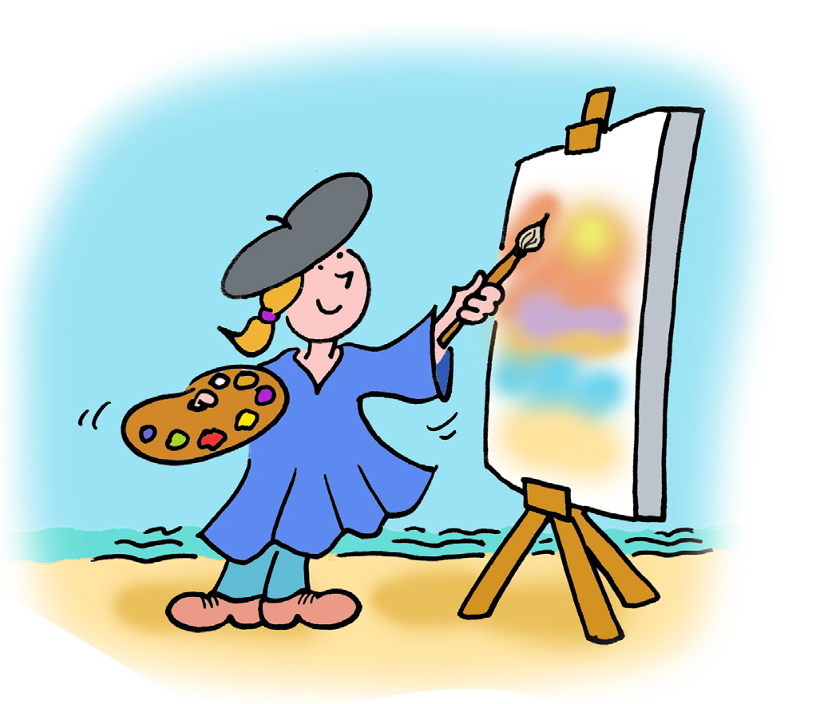
JMW Turner
Joseph Mallord William Turner was born in London in 1775. He was described by the art critic John Ruskin as ‘the greatest of the age’.

SUITABLE
ANY
TIDE

Turner was unusual because he painted outdoors when many of his contemporaries remained in their studios. He would paint at different times of day and in all weathers, revelling in reproducing sunrises, sunsets, mist, rain and snow. He once
famously had himself tied to the mast of a
ship in a storm so he could record the full effect of the weather!

He is often called a painter of light and his rendition of it is remarkable.

Turner loved Margate for the sea and the skies. He first came to Margate aged 11, having been sent to school in Love Lane. He returned to sketch here aged 21 and from the 1820s onwards became a regular visitor. It was the unique quality of light that drew him back. He said that ‘…the skies over Thanet are the loveliest in all Europe.’ More than one hundred of his works were inspired by the East Kent coast.

A comprehensive learning resource about Turner was produced for an exhibition at Turner Contemporary:
www.turnercontemporary.org/media/documents/DIGITAL%20Adventures%20in%20 Colour%20-%20Teacher’s%20Resource.pdf

The Turner Contemporary offers an extensive range of educational activities and resources. Spending half a day at the Turner Contemporary and half a day on the beach is a great combination. Contact the learning team for more information: www.turnercontemporary.org/learn

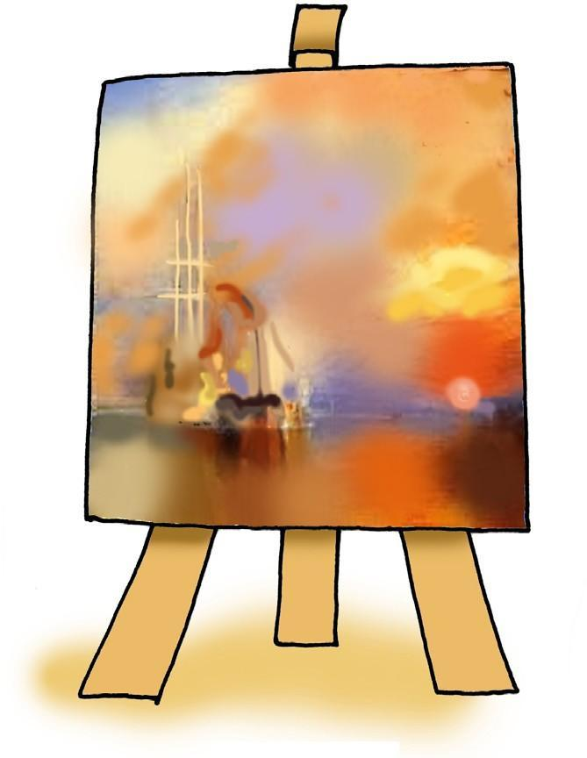
Before the visit
Look at paintings by Turner such as The Fighting Temeraire and The New Moon. They are fine examples of how he depicts light and water. Talk to the children about the painting. How do the paintings make them feel? Do they think Turner painted them slowly or quickly? Are the pictures better for not having detail in them?

During the visit
Use sketch books and paints, pencils or crayons to produce quick sketches of the sky and clouds concentrating on the blending of colours and the sense of atmosphere rather than detail.

After the visit
Have a go at producing your own ‘Turneresque’ images on large sheets of paper making reference to Turner’s paintings and the sketches produced on-site in the open air.

How to blend sky colours:
- Using plenty of yellow, brush on thick strokes horizontally across the page
- Add a small amount of red paint to your brush and stroke horizontally across the page, blending the two colours as you paint (this will make shades
of orange)
- Create lighter areas using the same method with white paint
- Brush across a tiny amount of blue or black to highlight darker areas (the red/ yellow/orange paint will turn brown

Try not to over-blend. The best effects will come from streaks of colour that are not entirely mixed.

Resources
You will need:
- Yellow, red, blue, black and white tempera paint
- Thick and thin brushes
- Paper

Suitable locations: Margate Main Sands, Joss Bay, Ramsgate, Minnis Bay

Wish You Were Here

KS2

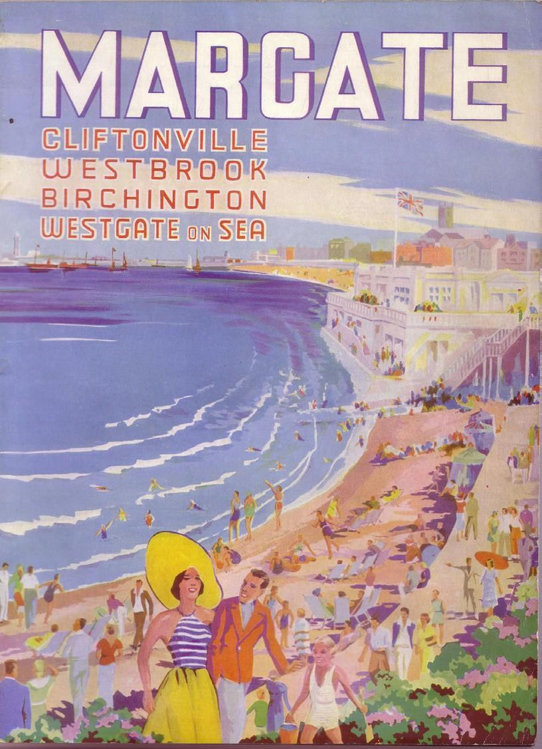
Learning Outcomes

ART
After taking part in this activity children will understand the popularity of seaside postcards in the past and what a broad range of designs were available. They will also have learned and applied their own design skills.

DESIGN
A
POSTCARD

Holiday postcards
Postcards are a distinctive type of written correspondence, designed to be posted without an envelope. The first postcard was sent to a writer in Fulham, London in
1840. In 1894 the Royal Mail allowed British publishers to make and distribute picture postcards through the post. They quickly became popular souvenirs, especially at seaside resorts like Margate, Ramsgate and
Broadstairs. People tend to write postcards in a writing style called Postcardese, with short, snappy sentences and often changing subject with each sentence, an early form of Twitter or texting?!

Before the visit
Introduce children to the varieties of seaside postcards using the examples in Wish You Were Here, Resource 6 and 7. Discuss what views and images are used and what design they would like to use for their own card.

During the visit
Children take photographs or make drawings to be used in their postcard design. Get children to think about what makes the place special and encourage them to create images that reflect this. What images would they want their friends and family to see of this place?

After the visit
Children select the images they think work best and use their selected template to create their own seaside postcard by cutting out images and pasting them onto the template. It is recommended that the templates are photocopied twice original size to make this easier.

Alternatively, children could design their own templates for postcards using familiar seaside objects such as buckets and spades, beach balls, kites, boats, rock pool creatures, seagulls etc.

You will need
Digital camera(s) and/or drawing materials.

Resources
Resource 6: Wish You Were Here, Historic Postcards. Resource 7: Wish You Were Here, Blank Postcards.
Resource 8: The Big Colouring-In Resource Contemporary seaside postcards could also be useful.

Suitable locations: Margate Main Sands, Joss Bay, Ramsgate, Minnis Bay

Go Fly a Kite

KS2
Learning Outcomes
After taking part in this activity children will understand the technical requirements necessary to build and fly a kite and they will also have learned and applied their own design skills.

DESIGN

Introduction
Flying a kite is great fun, but the experience is even more rewarding if it’s a kite you have made yourself.

SUITABLE
ANY
TIDE
The small paper kite is easy to make and based on a kite made by children in India to celebrate the Hindu festival of Makar Sankranti.

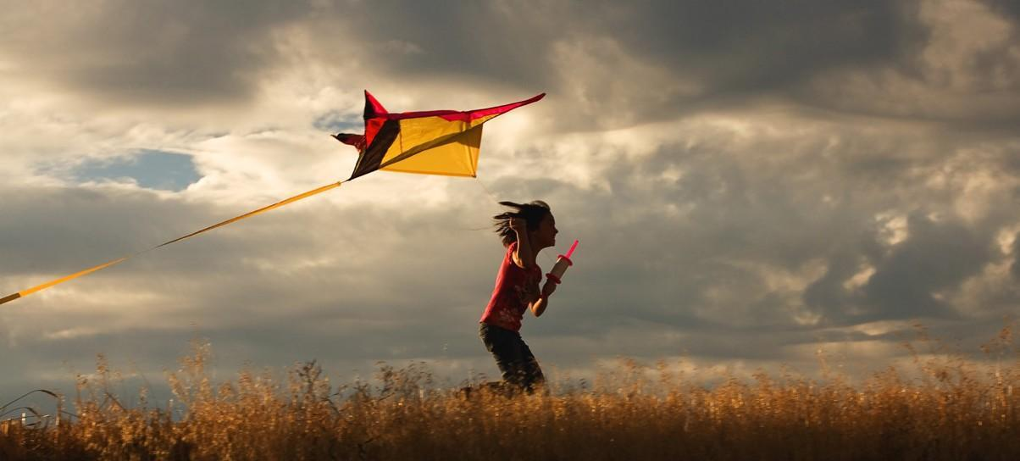
Before the visit
Use the instructions in Resource 9 to build and decorate your kites.

During the visit
Fly your kite!

Remember to be careful where you fly your kite. Beware of overhead lines, buildings
and other beach users. Have fun!

After the visit
Use your kites to make a beach scene wall display.

Discuss what it was like flying your kites and what methods you used to get your kite
airborne.

Resources
Resource 9: Go Fly A Kite, Instructions for making a kite.

Suitable locations: Margate Main Sands, Joss Bay, Ramsgate, Minnis Bay

Maritime Myths & Local Legends

KS
1&2

Learning Outcomes
After taking part in this activity children will understand how stories can offer a different perspective on local history and the natural world.

ENGLISH

Introduction
What’s the difference between a myth and a legend? Basically a myth is a made-up tale which usually attempts to explain something or some process that people did not understand, whereas a legend incorporates a grain of truth and often features a person or a recognisable landmark.

Myths and legends give shape to our past and the world around us. They help create a sense of place and cultural identity offering a shared ancestral memory. But stories are not static, they can change, become adapted and of course new stories are created all the time.

SUITABLE
ANY
TIDE

Coastal areas, such as Thanet, provide a rich source of tales having fired imaginations for thousands of years with stories of smuggling, invaders, ghost ships, sea monsters and pirates.

The audio stories contained in Resource 10 offer two marine myths, an enchanting tale of a hermit crab’s shell, and two local legends about smuggling. You can use these stories to inspire children’s writing, as discussion about different beliefs or as simple entertainment.

Before the visit
Listen to the stories. Do children think they are true? Are they accurate descriptions of natural phenomena such as the saltiness of the sea or the tides? How much of the legends do they think really happened?

During the visit
Search for ideas, objects and places that could be used to inspire a tale of a sea creature or a story that attempts to explain something.

After the visit
Use ideas gathered during the visit to produce a myth or legend for retelling in the classroom.

Resources
Resources 10: Maritime Myths and Local Legends, Five Audio Stories:
- Hermit Wants a Shell
- Sun, Moon and Water
- Why the Sea is Salty
- Joss Snelling the Smuggler
- The Smuggler’s Leap

Suitable locations: Margate Main Sands and Ramsgate

Holiday History

KS
1&2

Learning Outcomes
After taking part in this activity children will understand the popularity of the English seaside holiday from the Victorian period onwards. They will also have an insight into changing beach fashions and how holidaymakers enjoyed themselves in the past.

HISTORY

Introduction
During the 18th century bathing in the sea and drinking seawater became a fashionable cure for a variety of diseases. Visitors from London arrived on boats to stay in Thanet, initially for sea water cures but then as a place for socialising, leisure and pleasure.

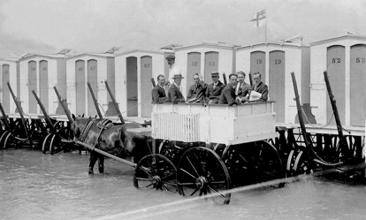
A common sight in the early days of seaside recreation was the wheeled bathing machine, designed to

SUITABLE
ANY
TIDE
protect the bather’s modesty. Benjamin Beale of Margate invented the earliest bathing machine. It was a complicated construction with an enormous canvas canopy that extended beyond the
machine to cover the area of water in which the bathers swam, thus keeping the bather safe from ‘the gaze of idle or vulgar curiosity.’

With the advent of the railways and cheap fares, holidays to the seaside became available to all, which meant the resorts of Thanet grew in popularity and size. Visitors came not just for the fresh sea air but entertainment as well. Walking along the promenade was popular and many seaside resorts extended this walk by building a pier from the end of which you could catch a steamer. On the beach, tourists could enjoy a Punch and Judy show, musical entertainers and donkey rides. Margate was the first resort to popularise donkey rides on the beach in the early 1800s.

There is a timeline in the Introduction section, with key dates in Thanet’s history.
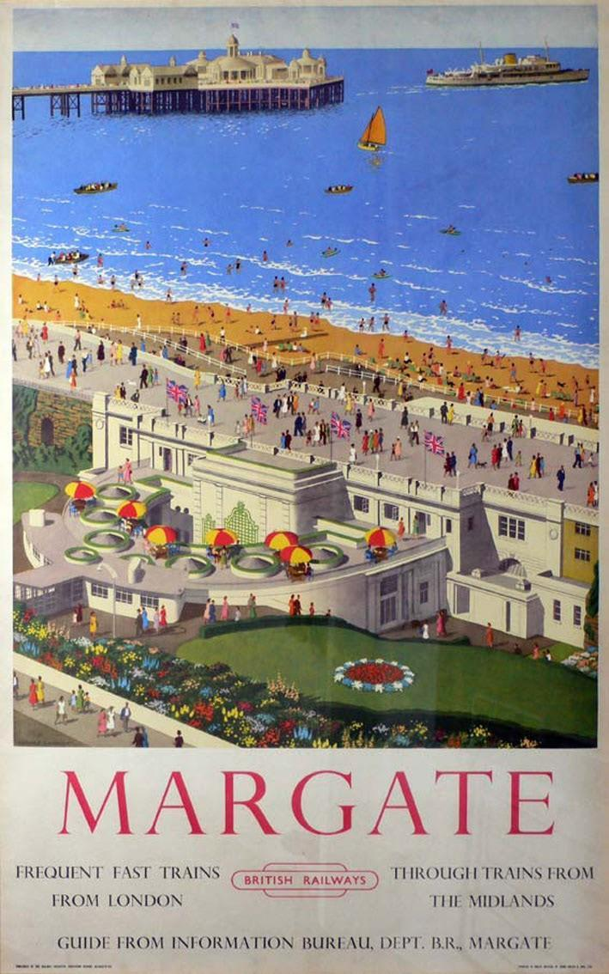
Seaside fashions have of course changed over the years and a look at early photographs makes you wonder if the heat of summer could really be enjoyed when wearing full Edwardian costume!

Resource 11 provides a selection of photographs from the Mick Tywman Archive showing holiday makers enjoying themselves long ago.

Margate Museum offers educational visits about seaside history, visit www.margatemuseum.org
for more information.

Before the visit
Look at the photographs in Holiday History Resource 11, Historic Photos and discuss the differences and similarities between holidays past and present. How do children think the holidaymakers in the photographs felt? Do they look like they are having fun?

During the visit
To add a little something extra to your fun-packed day at the beach you might like to recreate your own group photograph similar to those illustrated in Resource 11, Holiday History, Historic Photos.

After the visit
Create a display of your contemporary group photos alongside the Edwardian images highlighting the differences and similarities. Choose one of the children from a photograph, think about who they might be and where they could have come from and then, using a postcard design from the Wish You Were Here Activity write a postcard home describing what they might have done on the beach.

Resources
Resource 11: Holiday History, Historic Photographs Resource 12: Holiday History, Historic Brochures
You could also use Resource 7: Blank Postcards, for this Activity.

Suitable locations: Margate Main Sands, Joss Bay, Ramsgate, Minnis Bay

Changing Coasts

Learning Outcomes

KS2
After taking part in this activity children will understand how the coastline of Thanet has been shaped and changed by the sea and other natural forces and how those changes have been managed and will be managed for the future.

GEOG

Introduction
Thanet was once an island and is still referred to as ‘The Isle of Thanet’. The west and south-west coast were separated from the mainland by the Wantsum Channel. Over time this gradually silted up, land was reclaimed and Thanet ceased to be an island. The north, east and south coasts of Thanet were, and still are, subjected to the full force of the sea. Wave action eroded the soft chalk creating the cliffs that you see today.

SUITABLE
ANY
TIDE
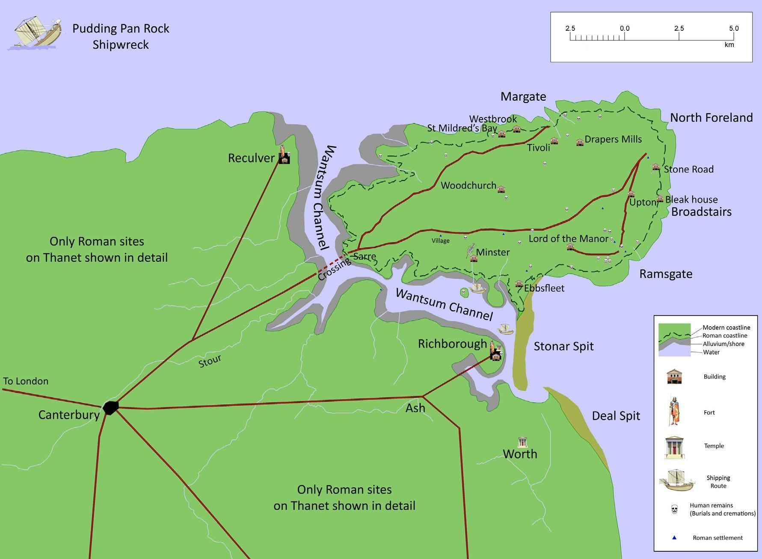
Reproduced with permission of Gerald Moody, author of Isle of Thanet.

Erosion is on-going and much of the Thanet coastline is currently protected by man- made defences in an effort to halt or slow this process. But in some places the cliffs are undefended and the natural process of erosion continues.

Erosion can happen under any conditions, but its rate tends to increase when waves are powerful and water levels are high - for instance during storms or in high winds. Eroded material is broken down, washed out to sea and is then deposited on the shore. The sand that makes the Thanet beaches is a product of erosion elsewhere along the coast.

Cliff erosion produces lots of interesting features such as caves, arches, stacks and wave-cut platforms. For an explanation of how erosion works and how these features are produced see Resource 13 and 14, Changing Coasts.

Before the visit
Introduce children to the concept of cliff erosion using the diagrams and photographs in Resources. Why do children think that along some parts of the Thanet coast the cliffs have been protected by sea walls and defences?

During the visit
Look out for examples of cliff erosion and coastal features like those outlined in Resources 13 and 14. The wave-cut platform is where you will find the rock pools for the Rock Pool Rummage activity. It’s worth getting the children to pause and think whilst rock pooling that they are standing where cliffs once stood.

After the visit
Produce a wall display featuring the basic coastal erosion features. You could also
include illustrations/photographs of any fossils you find.

Resources
Resource 13: Changing Coasts, Coastal Erosion Explained Resource 14: Changing Coasts, Cliff Formations

Suitable locations: Margate Main Sands, Joss Bay, Ramsgate, Minnis Bay

If Chalk Could Talk

Learning Outcomes

KS
1&2
After taking part in this activity, children will understand how old the chalk cliffs are, how they were formed and why they are important.

GEOG

Introduction
The Thanet coast has the longest continuous stretch of coastal chalk in Britain and, believe it or not, that chalk was being made when dinosaurs roamed the Earth! It’s important nationally and internationally, as Thanet has 20% of the UK’s and 13% of Europe’s coastal chalk.

About 85 million years ago a warm, tropical sea covered what is now Thanet. Living in that sea were coccoliths, microscopic marine algae. Their shells were made of calcite and as they died their bodies sank to the sea bed creating a chalky, muddy sediment. Over millions of years this sediment was compacted to become the chalk we see today. Since then falling sea levels and other geological events have elevated the ancient sea bed into the chalk cliffs that fringe the Thanet coast.

SUITABLE
ANY
TIDE

Chalk is a sedimentary rock because it is formed of compressed sediment. It is also
permeable because water can pass through it.

In amongst the chalk are layers of flint, a hard, impermeable rock made of silica derived from the skeletons of sponges and other marine creatures. The flint often formed in burrows of marine animals and along fault lines between the bedding planes of the chalk which is why you will often see lines of flint in the chalk cliff face and find knobbly nodules of flint on the beach. Flint was much prized by early man for making tools such as axes, knives and scrapers, and weapons such as arrow heads.

Many different types of fossils, such as urchins, echinoids and ammonites, can be found in the chalk.

Because chalk is sedimentary and porous it can be easily eroded and weathered by wind, rain and waves which means the chalk cliffs are often unstable. In many places along the Thanet coast the concrete sea defences have been built at the foot of the cliffs to stop this happening.

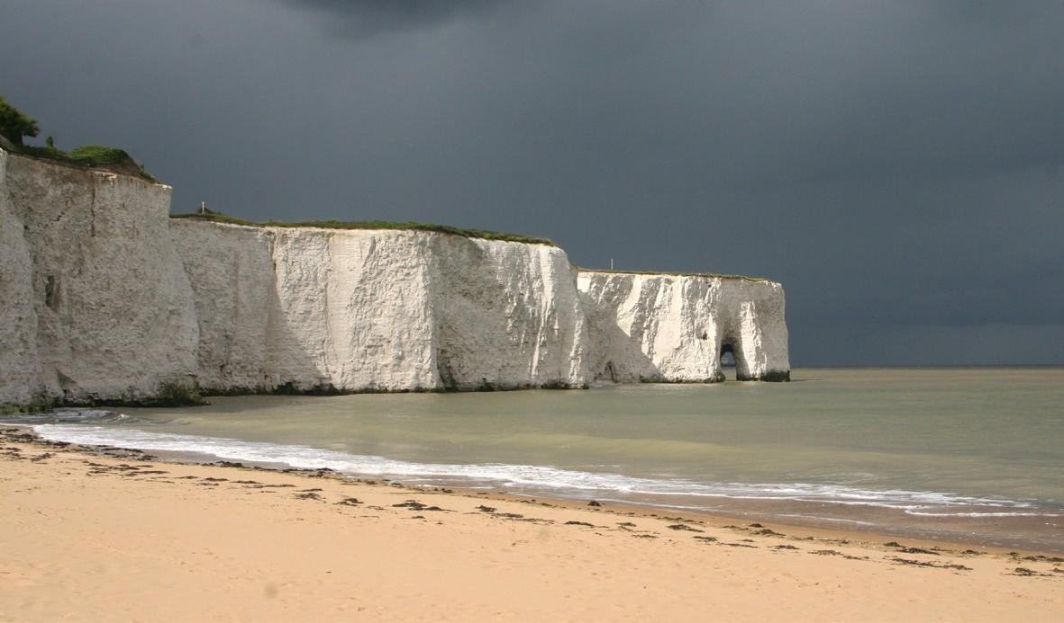
Before the visit
Get children to think about rocks. What do they think they are? What are the differences between certain rocks i.e. hard rocks and soft rocks?

During the visit
It is not recommended that you actively search for fossils at the foot of the cliffs as in places they are can be unstable and potentially dangerous.

After the visit
See Changing Coasts activity

Resources
Resource 13: Changing Coasts, Coastal Erosion Explained Resource 14: Changing Coasts, Cliff Formations
Resource 15: Common Chalk Fossils

Suitable locations: Margate Main Sands, Joss Bay, Ramsgate, Minnis Bay

What’s That Ship?

KS1

Learning Outcomes
After taking part in this activity children will be able to identify some of the different types of ship that pass through the busy English Channel.

GEOG

Maritime traffic around Thanet’s Coast
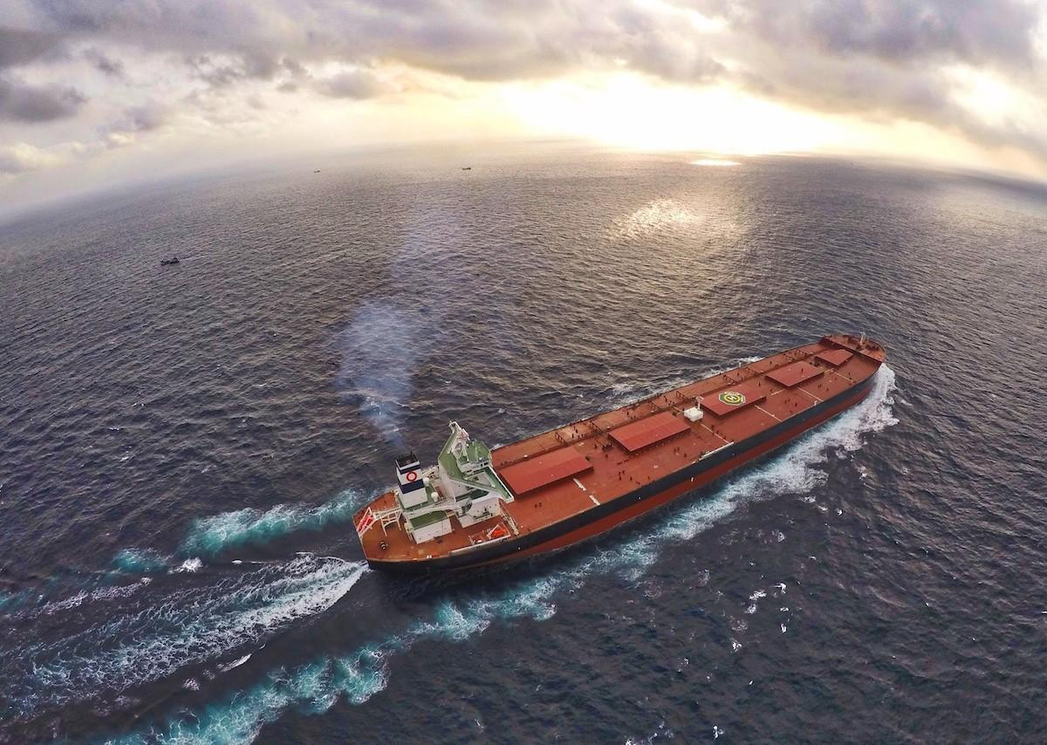
The sea off Thanet’s Coast is one of the busiest shipping lanes in the world, with over 500 ship movements each day. It links the North Sea and the English Channel with the Atlantic Ocean and is used by maritime transport and shipping as well as fishing boats and coastal pleasure craft.

SUITABLE
ANY
TIDE

Thanet’s coastline is dangerous and there have been many shipwrecks over the centuries. It is dangerous because of currents along the coastline and there are shifting and unstable sand banks offshore, such as the notorious Goodwin Sands, off the coast near Ramsgate. Beacons and lights have been lit on the coast for centuries, to help ships navigate safely around Thanet’s seas. The area around Joss Bay and North Foreland was particularly dangerous and there are records of a fire being lit at North Foreland in 1499.
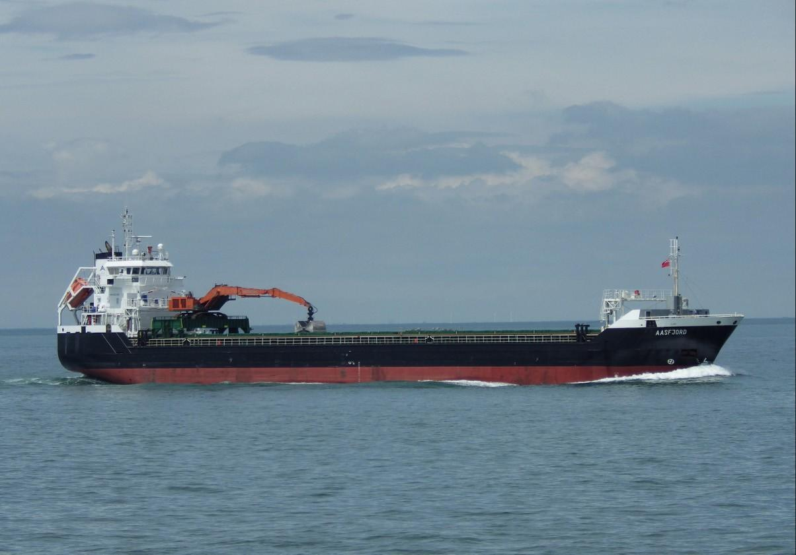
The first real lighthouse at Joss Bay was built in 1636 but was replaced by the current building in 1691. North Foreland lighthouse was the last lighthouse to be automated in the UK. It is now two private holiday cottages.

Ramsgate is England’s only Royal Harbour. It is a busy working port as well as a resort. There are cross-Channel freight ferries and smaller working craft such as pilot boats and Royal National Lifeboat Association boats as well as many pleasure craft.

Many ships seen around Thanet’s coast are travelling to the Port of London. They hire local pilot ships to help them navigate their route through the Thames Estuary. The lifeboat stations at Ramsgate and Margate are some of the oldest stations in the UK. Visit: www.rnli.org for more information.

The development of the Automatic Identification System (AIS) has made maritime traffic management much safer. You can see live vessel movements around the UK on this website: www.shipais.com It’s a fascinating website, constantly recording the freight and passenger ships traveling around the Thanet coast via a live Automatic Identification System (AIS).
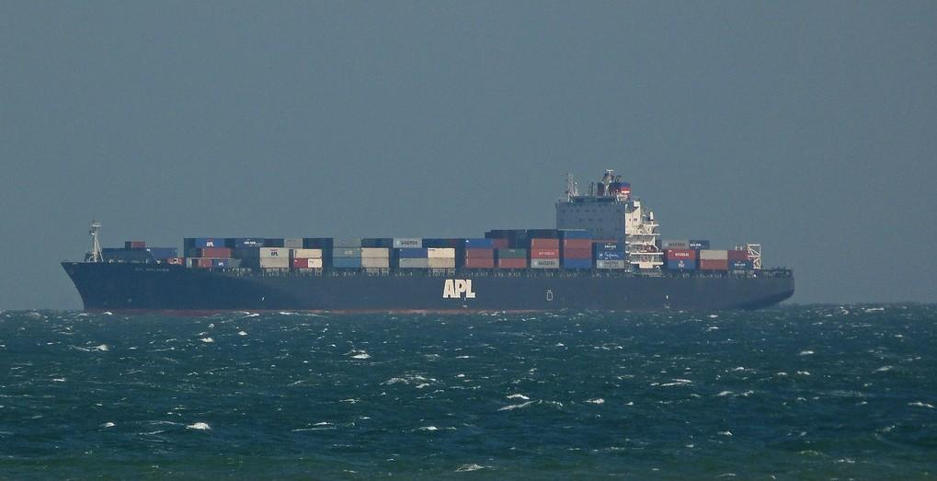

Before the visit

Make children aware of the fact that the English Channel is busy with ships from all over the world.
Show some images of the larger types of vessels such as container ships and tankers. Visit
www.shipais.com in the classroom shortly before your visit to Thanet to get an idea of the shipping in the area. Large international ships often anchor off the Thanet Coast, waiting for permission to enter the Port of London.

During the visit
Use Resource 16, What’s That Ship to help identify any ships you see out at sea. You can do this whilst having your lunch or snack.

After the visit
Talk with the children about the shipping that travels around Thanet’s coast, where it has come from, now and in the past.

Produce a plan showing the range of different ships that travel around Thanet, where they come from and what they are carrying.

Resources
Resource 16: What’s That Ship?

