Suitable locations: Margate Main Sands, Joss Bay, Ramsgate, Minnis Bay

Try a Turner

KS2
Learning Outcomes
After taking part in this activity children will have an understanding of artistic techniques for depicting clouds and sky, together with a deeper appreciation of the art of JMW Turner.
ART

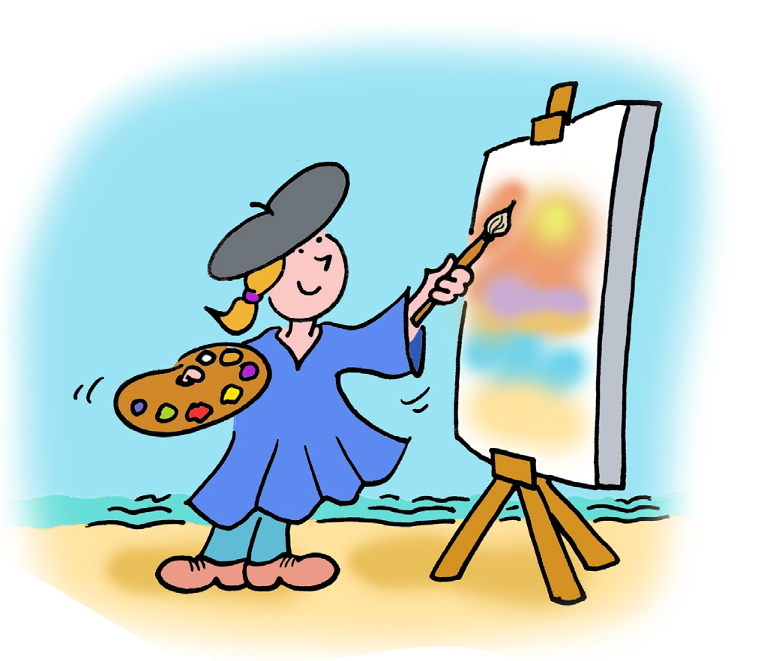
JMW Turner
Joseph Mallord William Turner was born in London in 1775. He was described by the art critic John Ruskin as ‘the greatest of the age’.

Turner was unusual because he painted outdoors when many of his contemporaries remained in their studios. He would paint at different times of day and in all weathers, revelling in reproducing sunrises, sunsets, mist, rain and snow. He once
SUITABLE
ANY
TIDE
famously had himself tied to the mast of a
ship in a storm so he could record the full effect of the weather!

He is often called a painter of light and his rendition of it is remarkable.

Turner loved Margate for the sea and the skies. He first came to Margate aged 11, having been sent to school in Love Lane. He returned to sketch here aged 21 and from the 1820s onwards became a regular visitor. It was the unique quality of light that drew him back. He said that ‘…the skies over Thanet are the loveliest in all Europe.’ More than one hundred of his works were inspired by the East Kent coast.

A comprehensive learning resource about Turner was produced for an exhibition at Turner Contemporary:

The Turner Contemporary offers an extensive range of educational activities and resources. Spending half a day at the Turner Contemporary and half a day on the beach is a great combination. Contact the learning team for more information: www.turnercontemporary.org/learning

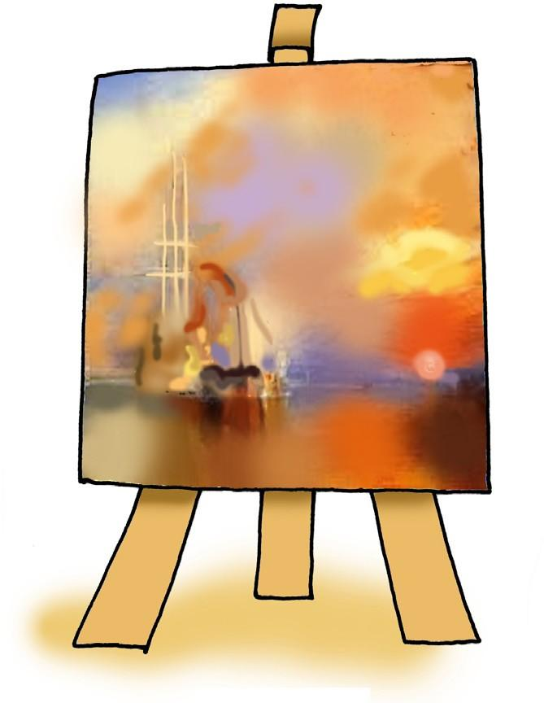
Before the visit
Look at paintings by Turner such as The Fighting Temeraire and The New Moon. They are fine examples of how he depicts light and water. Talk to the children about the painting. How do the paintings make them feel? Do they think Turner painted them slowly or quickly? Are the pictures better for not having detail in them?

During the visit
Use sketch books and paints, pencils or crayons to produce quick sketches of the sky and clouds concentrating on the blending of colours and the sense of atmosphere rather than detail.

After the visit
Have a go at producing your own ‘Turneresque’ images on large sheets of paper making reference to Turner’s paintings and the sketches produced on-site in the open air.

How to blend sky colours:
- Using plenty of yellow, brush on thick strokes horizontally across the page
- Add a small amount of red paint to your brush and stroke horizontally across the page, blending the two colours as you paint (this will make shades of orange)
- Create lighter areas using the same method with white paint
- Brush across a tiny amount of blue or black to highlight darker areas (the red/ yellow/orange paint will turn brown

Try not to over-blend. The best effects will come from streaks of colour that are not entirely mixed.

Resources
You will need:
- Yellow, red, blue, black and white tempera paint
- Thick and thin brushes
- Paper

