Suitable locations: Margate Main Sands, Joss Bay, Ramsgate, Minnis Bay

Resource 9: Instructions for making a kite

You will need:

KS2
- A4 sized craft papers in contrasting colours
- Drinking straws
- Glue
DESIGN
- Cotton
- Long strips of coloured paper or ribbons for the tail

How to make your kite:
- Fold A4 sheet of coloured craft paper in half length ways (Fig. 1)
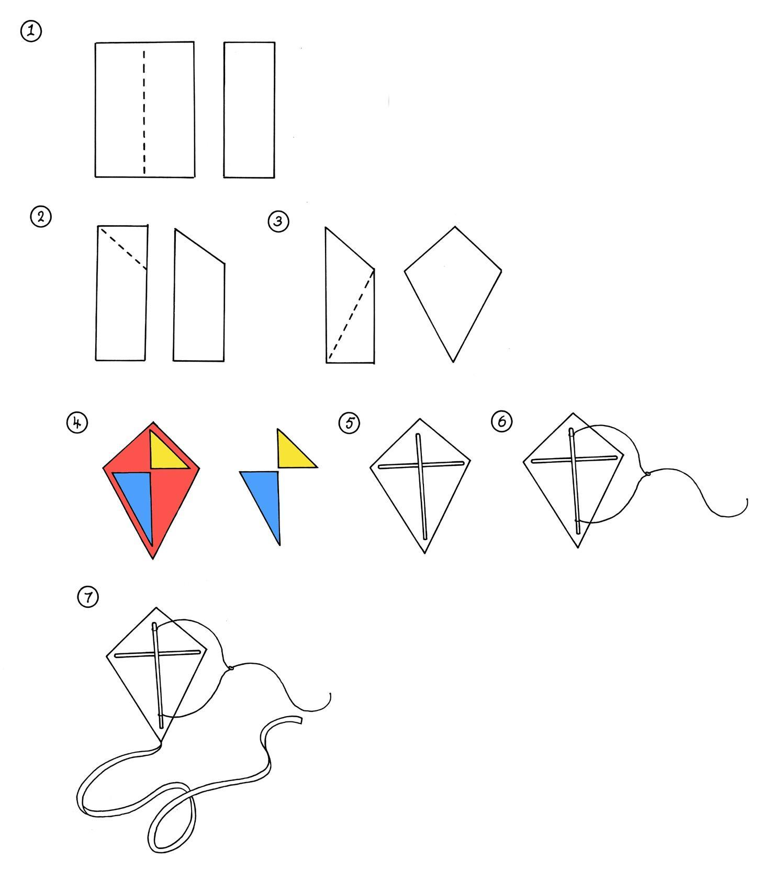
- Fold the top corner into the middle and cut this corner off. Save the off cuts from the different coloured papers to use as decoration on your kite. (Fig. 2)
- Draw a line as shown in fig. 3 and cut along it. Again save the
off cut pieces as decoration. Unfold to reveal a diamond shape kite.
- Use the off cuts to decorate one side of the kite (Fig.4)
- You now need to attach the straw struts. Cut the straws to length, turn the kite over and attach the straws with glue (Fig.5)
- Thread a length of thin string or cotton through the vertical straw and tie in a loop (fig. 6)
- Attach a long crepe paper tail (Fig.7)
- Attach a length of string to the loop and your kite is ready to fly.

