Suitable locations: Margate Main Sands, Joss Bay, Ramsgate, Minnis Bay

If Chalk Could Talk

KS
1&2

Learning Outcomes
After taking part in this activity, children will understand how old the chalk cliffs are, how they were formed and why they are important.

GEOG

Introduction
The Thanet coast has the longest continuous stretch of coastal chalk in Britain and, believe it or not, that chalk was being made when dinosaurs roamed the Earth! It’s important nationally and internationally, as Thanet has 20% of the UK’s and 13% of Europe’s coastal chalk.

SUITABLE
ANY
TIDE

About 85 million years ago a warm, tropical sea covered what is now Thanet. Living in that sea were coccoliths, microscopic marine algae. Their shells were made of calcite and as they died their bodies sank to the sea bed creating a chalky, muddy sediment. Over millions of years this sediment was compacted to become the chalk we see today. Since then falling sea levels and other geological events have elevated the ancient sea bed into the chalk cliffs that fringe the Thanet coast.

Chalk is a sedimentary rock because it is formed of compressed sediment. It is also
permeable because water can pass through it.

In amongst the chalk are layers of flint, a hard, impermeable rock made of silica derived from the skeletons of sponges and other marine creatures. The flint often formed in burrows of marine animals and along fault lines between the bedding planes of the chalk which is why you will often see lines of flint in the chalk cliff face and find knobbly nodules of flint on the beach. Flint was much prized by early man for making tools such as axes, knives and scrapers, and weapons such as arrow heads.

Many different types of fossils, such as urchins, echinoids and ammonites, can be found in the chalk.

Because chalk is sedimentary and porous it can be easily eroded and weathered by wind, rain and waves which means the chalk cliffs are often unstable. In many places along the Thanet coast the concrete sea defences have been built at the foot of the cliffs to stop this happening.

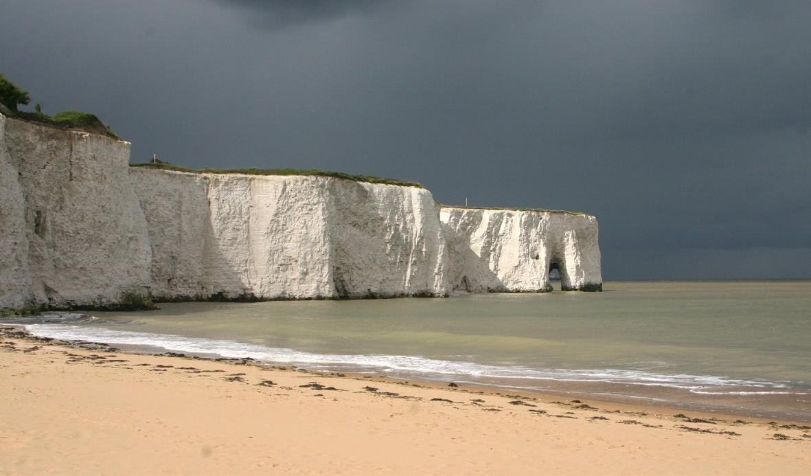
Before the visit
Get children to think about rocks. What do they think they are? What are the differences between certain rocks i.e. hard rocks and soft rocks?

During the visit
It is not recommended that you actively search for fossils at the foot of the cliffs as in places they can be unstable and potentially dangerous.

After the visit
See Changing Coasts activity

Resources
Resource 13: Changing Coasts, Coastal Erosion Explained
Resource 14: Changing Coasts, Cliff Formations
Resource 15: Common Chalk Fossils

