Suitable locations: Margate Main Sands, Joss Bay, Ramsgate, Minnis Bay

Resource 13: Changing Coasts

KS2

Cliff erosion

GEOG
- Waves gradually begin to create a notch at the base of the cliff.
- The wave-cut notch undercuts the cliff.
- Eventually the cliff becomes unsupported and collapses into the sea.
- As the cliff retreats it leaves behind a wave-cut platform which can be seen at low tide. Look out for the wave-cut platforms at Minnis Bay and Joss Bay.

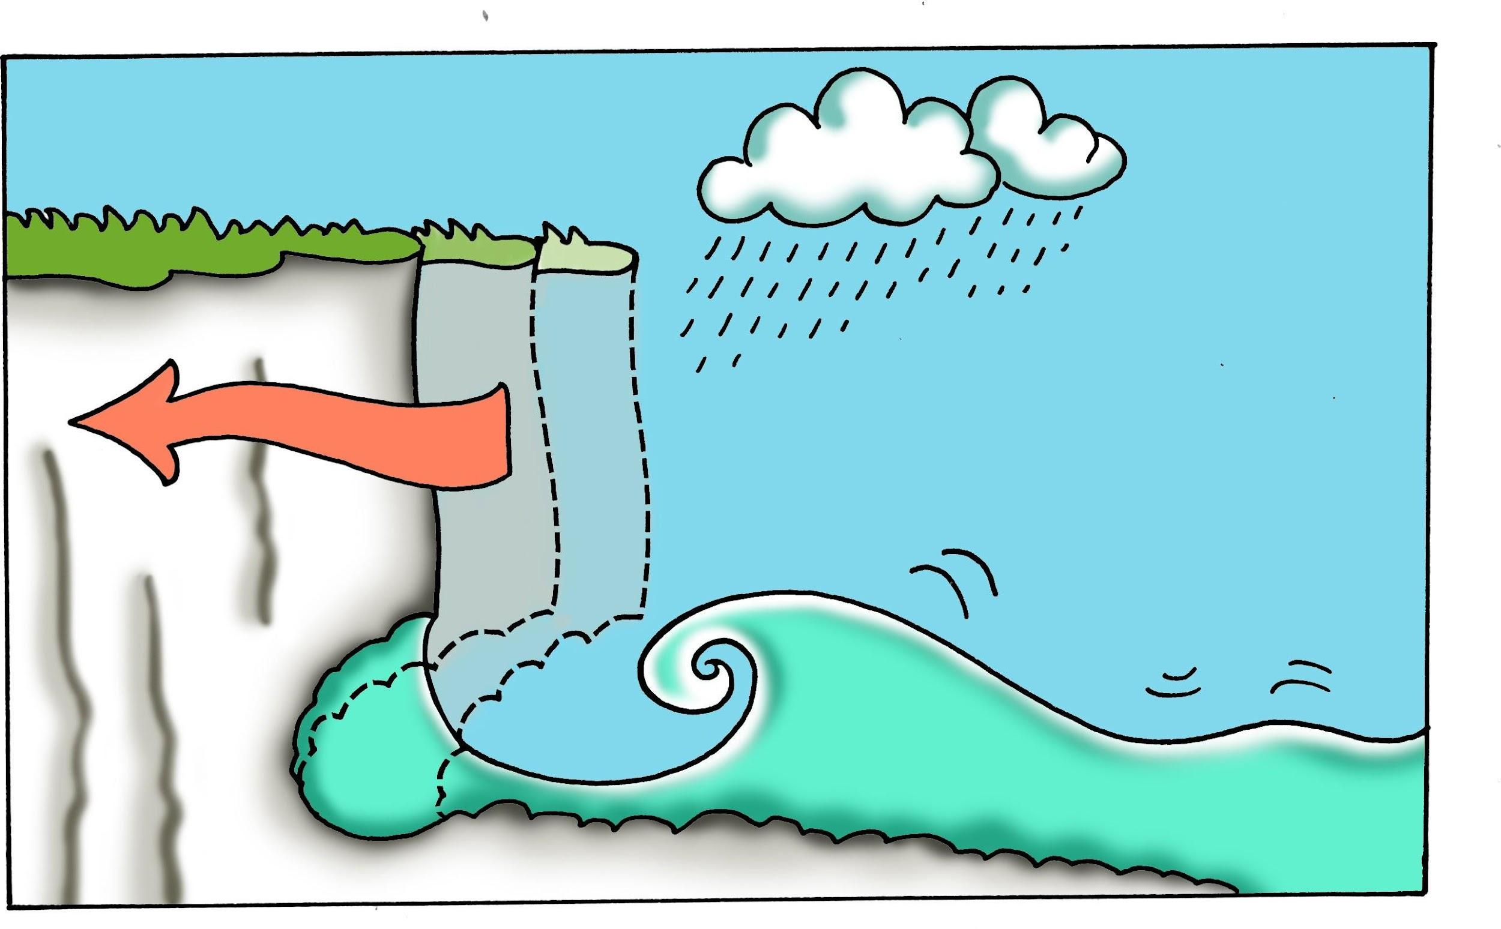

Cliff formations
- All rocks have lines of weakness.
- Waves find these lines of weakness and begin to erode them faster and deeper
than the surrounding rock.
- These lines of weakness get enlarged and develop into small sea caves (there are examples at Kingsgate Bay and Pegwell Bay, although some of the Thanet sea caves can be the entrances to man-made tunnels.)
- If the caves are eroded on either side of a headland the sea eventually cuts through, forming an arch (a fine example of an arch can be seen from Kingsgate Bay).
- The rock at the top of the arch becomes unsupported as the arch is enlarged and eventually collapses to form a stack (cliff stacks can be seen at Botany Bay).
- The stack is slowly eroded until only a stump remains which in turn eventually disappears.

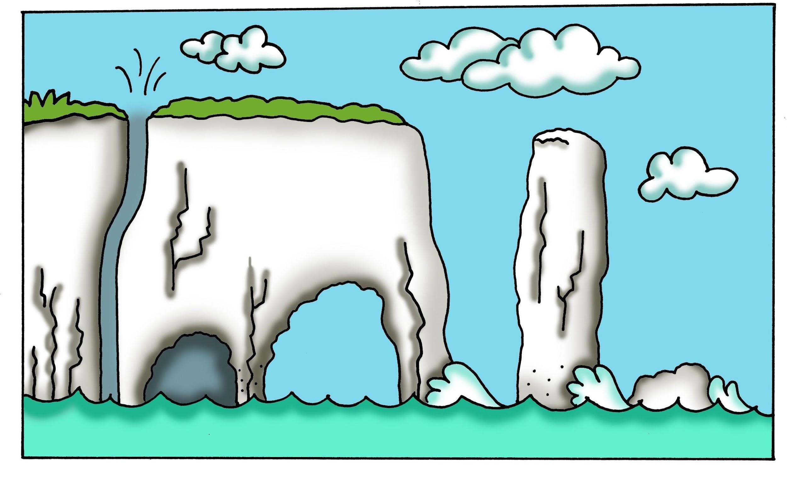

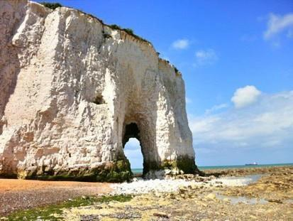
Wave-cut arch and wave-cut platform at Kingsgate Bay.
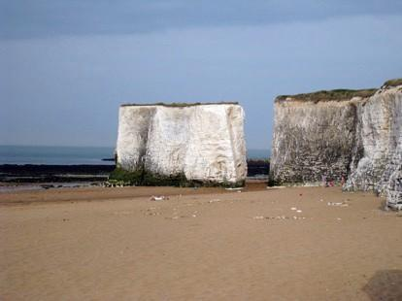
Chalk stacks at Botany Bay

